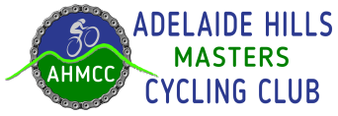 [](https://samc.org.au/)

**The AHMCC in association with SAMCA present the**

**ADELAIDE HILLS TOYOTA CLASSIC**

**Open Graded Scratch Race**

**October 16, 2016**

**Gilbert’s**



**Principal Sponsor of the Adelaide Hills Toyota Classic**

**Three Race Distances**

**Grades A,B&C - 91 kms D&E - 71 kms F&G - 56.5 kms**

**SPRINT and KOM awards Motoring vouchers donated by**

**donated by**

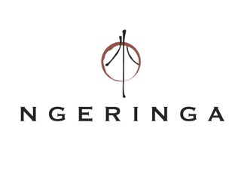  

**Registration: From 8.00am at Wistow Hall**

**Race Start: 9.30am**

**Nominations to: Nominations on SAMCA website**

**Pay on race day**

**Nominations details: $15. Up to 9pm Wednesday 12th October**

**$20. CLOSE 7pm Thursday 13th October**

**Timing system:** **Orion transponders to be used. Available for hire ($5)**

**Course:** **Course 20. AHMCC website**

**Presentations: Wistow Hall. Light luncheon provided**

**Enquiries: Sarah Rawlinson 0409 910 079**