ADELAIDE HILLS CYCLING CLUB
WOODCHESTER TIME TRIAL COURSE
Distances: full loop = 22.2ks (11.1 ks each way)

WOODCHESTER
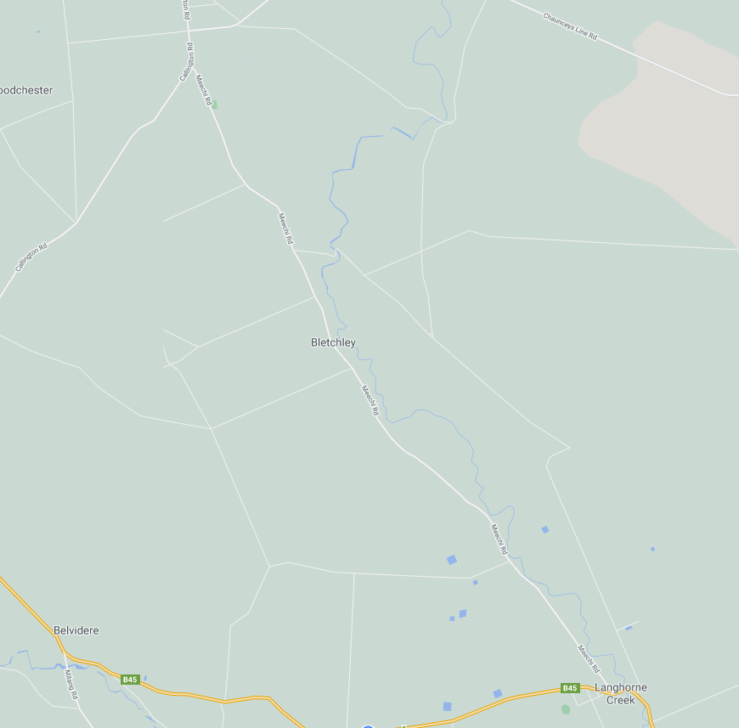

ZONE 2: See detailed map below
TURN AROUND
80

ZONE 1: See detailed map below
LANGHORNE CREEK ROAD
100
80
100
START
LANGHORNE CREEK
MEECHIE ROAD
CALLINGTON ROAD
FINISH
60

ZONE 1: START AREA
ALL SIGNAGE IS PLACED WITHIN A STANDARD 100KM SPEED ZONE

WOODCHESTER
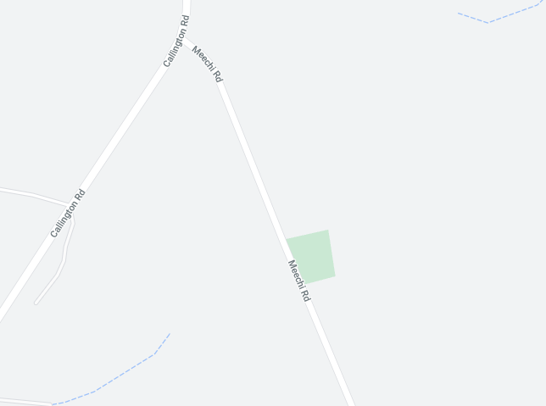
MULTI MESSAGE
Event AHEAD
Event bike
Speed restriction ahead - 40
MULTI MESSAG (X2)
Event AHEAD
Speed restriction - 40
Speed resumption - 100

MARSHAL
MULTI MESSAGE (X2)
PREPARE TO STOP
SPEED RESTRICTION - 40
SPEED RESUMPTION - 100
MULTI MESSAGE
Event AHEAD
Event bike
Speed restriction ahead - 40
START
FINISH
MEECHIE ROAD
CALLINGTON ROAD

ZONE 2: TURNAROUND POINT
ALL SIGNAGE IS PLACED WITHIN A STANDARD 80KM SPEED ZONE

MULTI MESSAGE
Event AHEAD
Event bike
Speed restriction ahead - 40

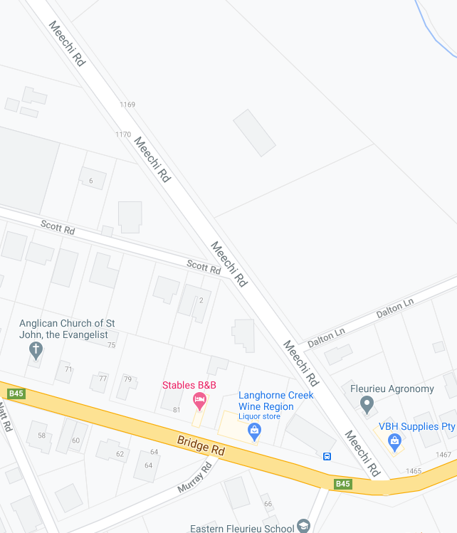
SAFETY CONES X 2
TURN AROUND
SCOTT ROAD
MULTI MESSAGE
Event AHEAD
Event bike
Speed restriction ahead - 40
MULTI MESSAGE (X2)
PREPARE TO STOP
SPEED RESTRICTION - 40
SPEED RESUMPTION - 80
80
MEECHIE ROAD
MARSHAL
60
MARSHAL
MULTI MESSAGE (X2)
PREPARE TO STOP
SPEED RESTRICTION - 40
SPEED RESUMPTION - 80
LANGHORNE CREEK

