
KENNELS-TO-BLACKBURN HILL CLIMB
Kennels to top of Blackburn Drive

Distance - 7.6 km. Climb - 350 meters
START
At ‘The Kennels’, on the Tollgate to Bollards veloway
MT OSMOND
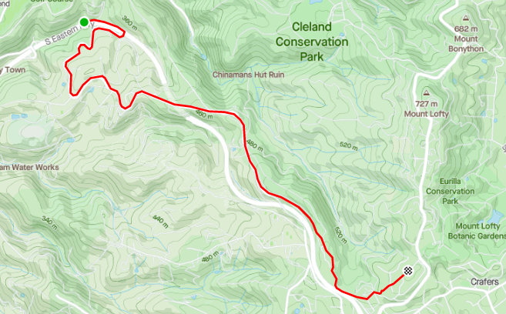
FINISH
Top of Blackburn Dr, Crafers
CRAFERS
BLACKBURN DR
MT BARKER RD VELOWAY
