CORKSCREW HILL CLIMB
Corkscrew Road to Marble Hill
Distance: 7.9 km: Climb: 446 meters
START
Start at the Sixth Creek Bridge, Corkscrew Rd
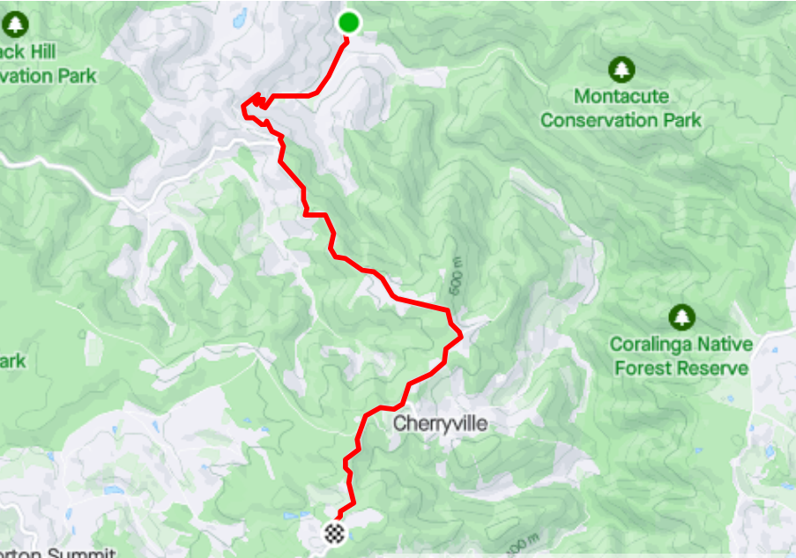
MARBLE HILL RUINS
MONTACUTE RD
CHERRYVILLE
FINISH
Marble Hill
MONTACUTE RD
CORKSCREW RD

