 MONTACUTE HILL CLIMB SIGNAGE MAP
Distance:
From start to finish point = 10.7 km

ATHELSTONE
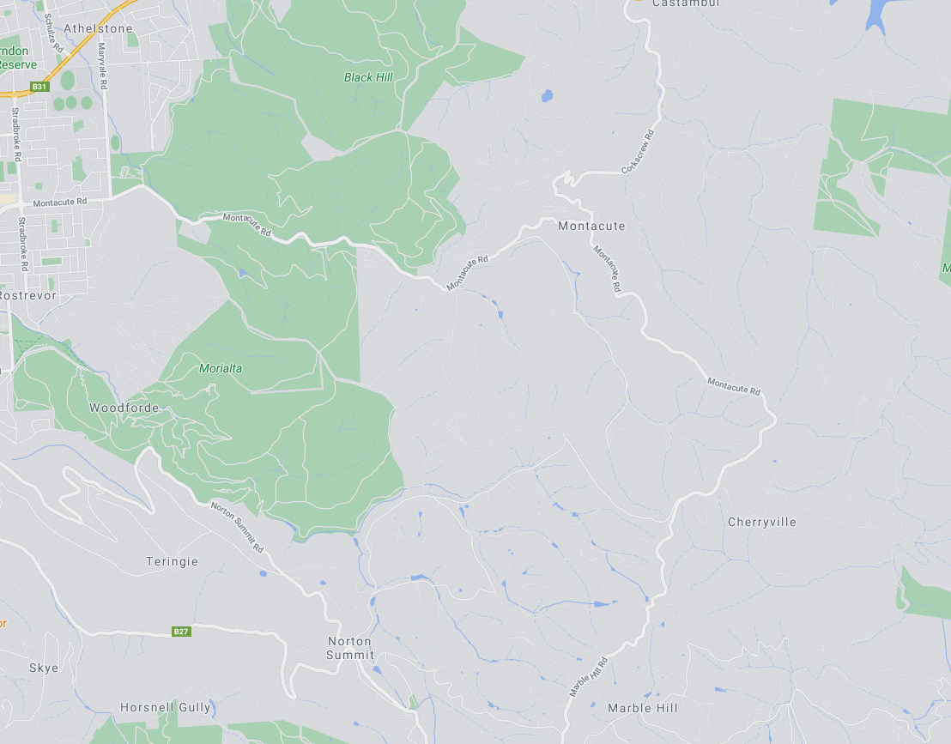
ZONE 2: See detailed map below
MONTACUTE RD
MARYVALE RD
ZONE 1:
See detailed
map below
60
60
80
START
Corner of Montacute Rd and Maryvale Rd
80
MARBLE HILL RD
MONTACUTE
MONTACUTE RD
CHERRYVILLE
MARBLE HILL RUINS
FINISH
Marble Hill
CORKSCREW RD

ZONE 1: START AREA
ALL SIGNAGE IS PLACED WITHIN A STANDARD 60KM SPEED ZONE

Start point: is in a parking area on the side of Montacute Rd. Riders will not be congregating on the road.

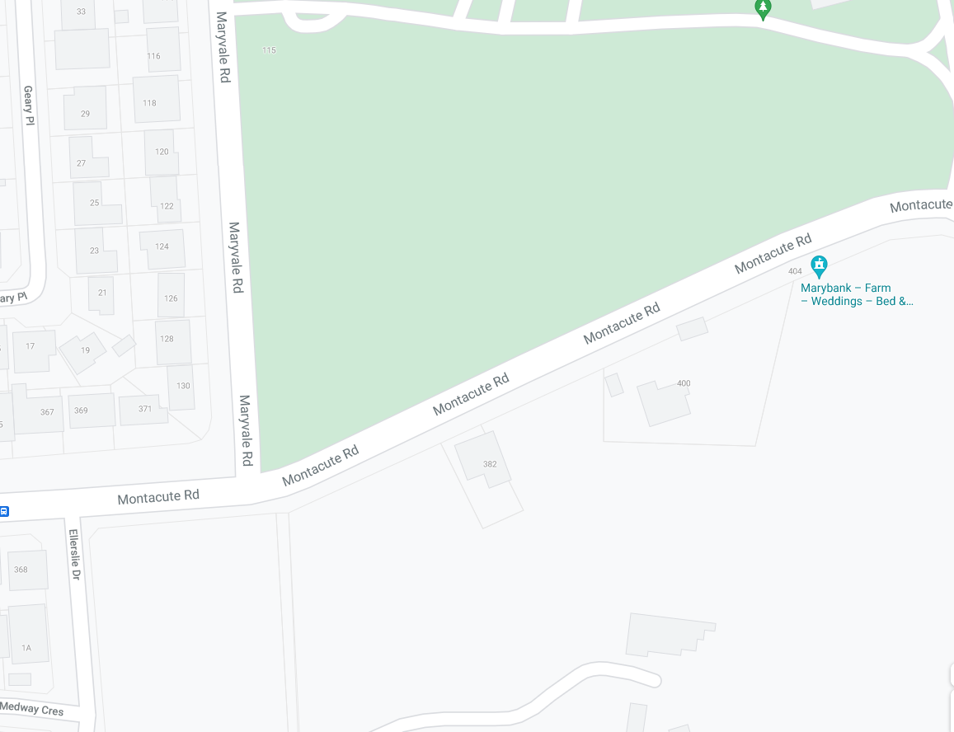
Event AHEAD
MULTI MESSAGE (X2)
PREPARED TO STOP
SYMBILC CONTROLLER
Speed restriction – 40
Speed resumption – 60
END EVENT

MULTI MESSAGE (X2)
PREPARED TO STOP
SYMBOLIC CONTROLLER
Speed restriction – 40
Speed resumption - 60

MULTI MESSAGE (X2)
PREPARED TO STOP
SYMBOLIC CONTROLLER
Speed restriction – 40
Speed resumption – 60
END EVENT

Event AHEAD
MARSHAL
MARYVALE RD
MONTACUTE RD
MONTACUTE RD
Event AHEAD
START

ZONE 2: FINISH AREA
ALL SIGNAGE IS PLACED WITHIN A STANDARD 80KM SPEED ZONE

80kph fixed sign – covered for duration of event
MULTI MESSAGE
Event AHEAD
Event bike
Speed restriction ahead - 40
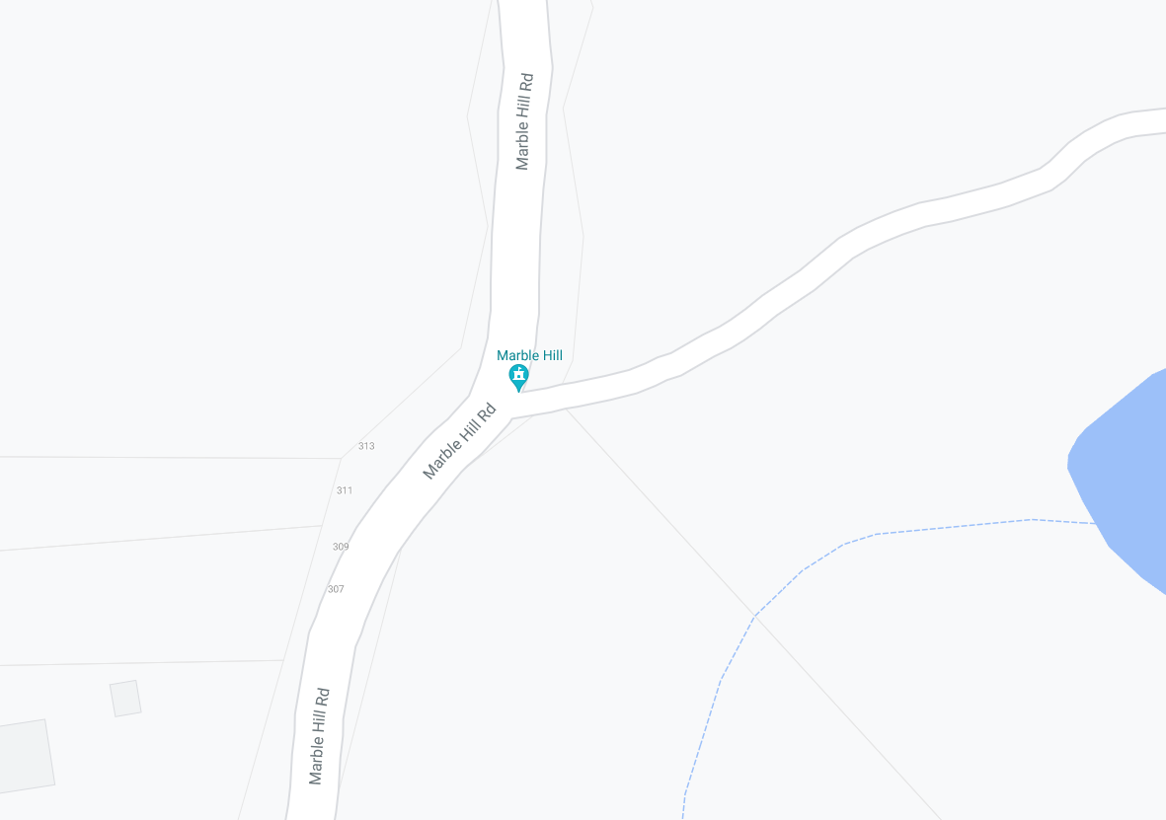
MULTI MESSAGE
PREPARE TO STOP
SYMBOLIC CONTROLLER
Speed restriction – 40
Speed resumption – 80
END EVENT

MULTI MESSAG
PREPARE TO STOP
SYMBOLIC CONTROLLER
Speed restriction – 40
Speed resumption - 80

MARBLE HILL RD
MARBLE HILL RD
Finish
MULTI MESSAGE
Event AHEAD
Event bike
Speed restriction ahead - 40

