
BRADBURY KERMESSE COURSE MAP
Full loop from finish point = 5.8 km
Distance from start to finish point = 900 meters
MYLOR
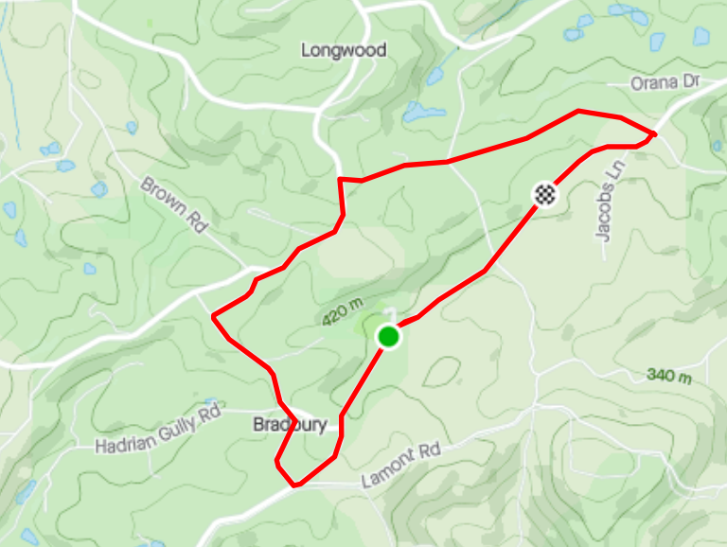
BRADWOOD PARK OVAL
REGO: Bradwood Park Oval, Bradbury Rd, Bradbury
LONGWOOD RD
START: Bradbury Rd, at the entrance to Bradwood Park Oval
FINISH: Bradbury Rd, 900m from the start point
LONGWOOD
BRADBURY RD
LONGWOOD RD
RIDGE RD
BRADBURY RD
BRADBURY
