
FORRESTON COURSE MAP
Full loop from finish point = 16.6 km
Distance from start to finish point = 6 km
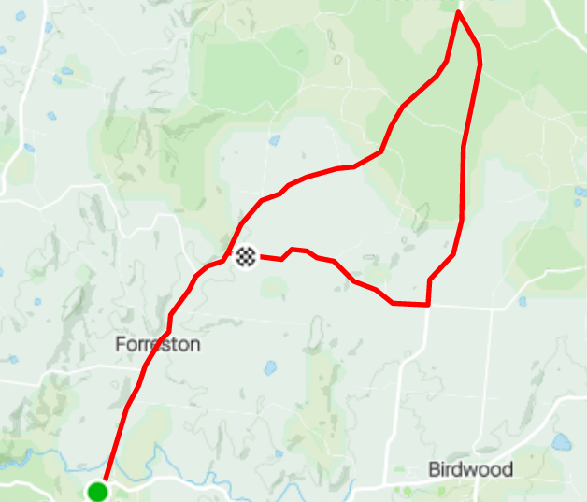
GUMERACHA
TOWN HALL
FINISH: Martin Hill Rd
REGO and START: Gumeracha Town Hall, 45 Albert St, Gumeracha.
MARTIN HILL RD
FORRESTON RD
WARREN RD
BIRDWOOD
FORRESTON
FORRESTON RD
