
FOX CREEK COURSE MAP
Start lap: start point to finish line = 17 km
Full loop from finish line = 16.6 km
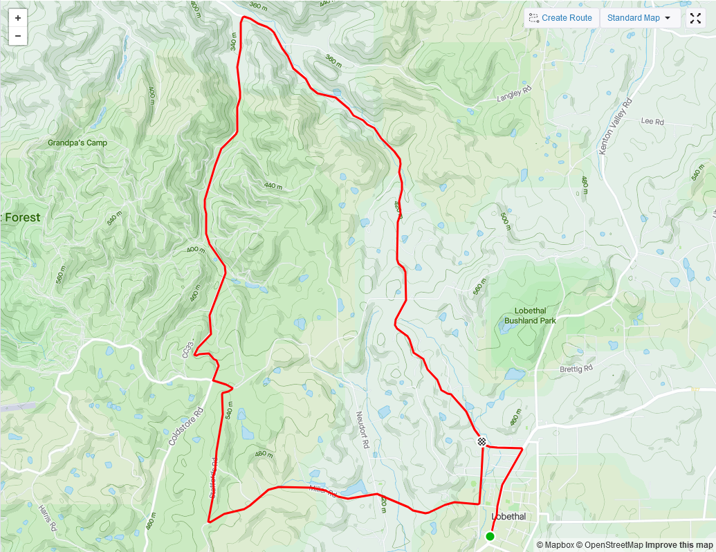
REGO: Lobethal Centennial Hall, 36 Main Street, Lobethal
LOBETHAL
START: Bierhaus car park – 3A Main Street, Lobethal
FINISH: Post Office Rd, Lobethal
STAFFORDS RD
KENTON VALLEY
CUDLEE CREEK
LENSWOOD
CUDLEE CREEK RD
CUDLEE CREEK RD
CROFT RD
POST OFFICE RD
MILLER RD
FOX CREEK RD

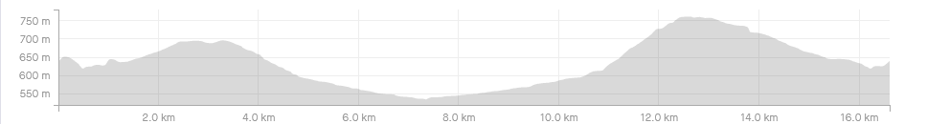
MACCLESFIELD
STRATHALBYN RD
BUGLE RANGE RD

