
HARROGATE RD COURSE MAP
Start at Harrogate. Head out along Harrogate Rd. Loop(s) of Harrogate Rd then finish on Mail Rd
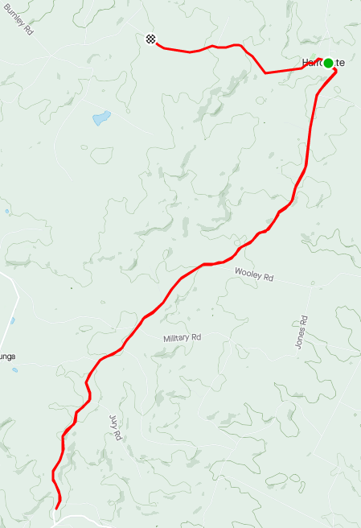
HARROGATE RD
MAIL RD
Mail Rd (plus start to beginning of the Harrogate Rd loop) = 7.1 km
Harrogate Rd loop = 19.4 km
REGO: Harrogate Soldiers Memorial Hall, 13 Mail Rd, Harrogate
FINISH: Mail Rd
START: Corner of Mail Rd and Harrogate Rd, Harrogate.
OLD PRINCESS HWY
TEE RD
HARROGATE RD
HARROGATE
