MONTACUTE HILL CLIMB
REGO: Foxfield Oval, 88 Maryvale Rd, Athelstone
Maryvale Road to Marble Hill
Distance: 10.7 km: Climb: 430 meters
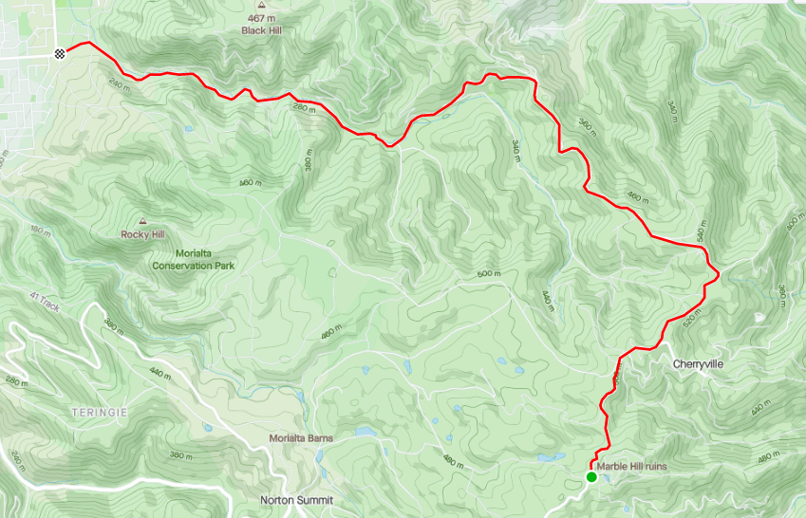
FINISH
Marble Hill
START: Corner of Montacute Rd and Maryvale Rd, Athelstone
CORKSCREW RD
MONTACUTE RD
MONTACUTE RD
MARBLE HILL RUINS
CHERRYVILLE

