
OAKWOOD RD COURSE MAP
Full loop = 8.96 km
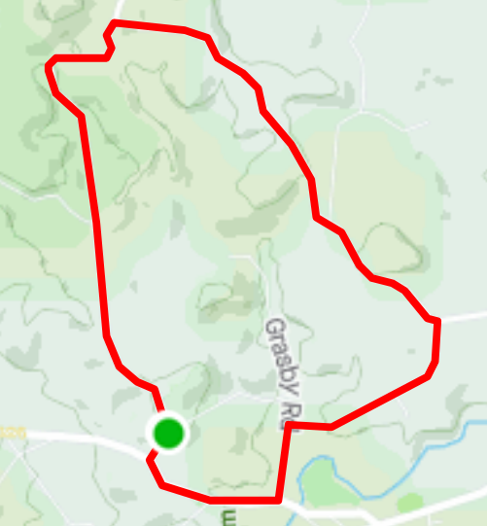
GREENHILL RD
REGO: Balhannah Scout Hall, Pye Rd, Balhannah
GRASBY RD
START: Corner of Pye Rd and Swamp Rd, Balhannah
FINISH: Swamp Rd, 200m up from the start point
OAKWOOD RD
BALHANNAH
GREENHILL RD
SWAMP RD
PYE ROAD
HALL
GREENHILL RD
SWAMP RD
WICKS RD
OAKWOOD RD
