
SPRINGHEAD RD COURSE MAP
Start lap: start point to finish line = 8.4 km
Full loop from finish line = 9.7 km
START:
Cnr Mount View Rd and Townsend Rd
REGO: Mt Torrens Oval, Oval Rd, Mt Torrens
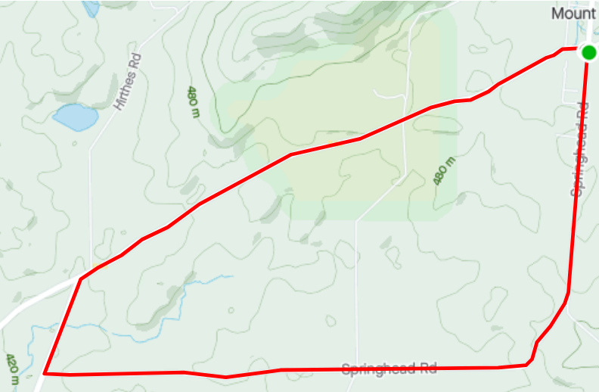
FINISH: Springhead Rd
MT TORRENS
ONKAPARINGA VALLEY RD
ONKAPARINGA VALLEY RD
SPRINGHEAD RD
ONKAPARINGA VALLEY RD
SPRINGHEAD RD
SPRINGHEAD RD

