
STAMPS RD COURSE MAP
Start lap: start point to finish line = 3.3 km
Full loop from finish line = 12.9 km

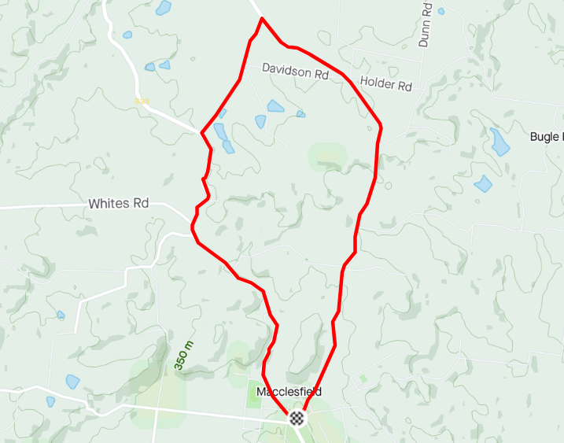
REGO: Macclesfield Oval, Kingrose St, Macclesfield
START: Davenport Squ, Macclesfield
FINISH: Stamps Rd – 3.3ks from the start
MACCLESFIELD
FLAXLEY
STAMPS RD
STRATHALBYN RD
BUGLE RANGE RD
FLAXLEY RD
STAMPS RD
