
TERLINGA RD COURSE MAP
Full loop: Start point, out and back to finish point = 21.9 km:
Shorter loops: Turnaround point 1 to turnaround point 2 and back again = 18.8 km
Turnaround point 1 to finish = 1.5 km
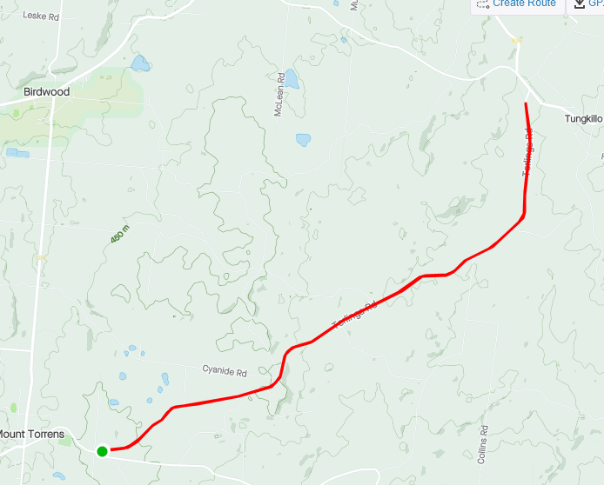
TUNGKILLO RD
MT TORRENS
BIRDWOOD
ONKAPARINGA VALLEY RD
REGO: Mt Torrens Hall, Oval Rd, Mt Torrens
START: Corner of Terlinga Rd and Blackheath Rd
FINISH: Terlinga Rd, 200m from the start point
TURNAROUND POINT 2
TURNAROUND POINT 1
TERLINGA RD
BLACK HEATH RD
