 FORRESTON COURSE SIGNAGE MAP
Distances:
From start to finish point = 6 km
Martin Hill, Warren, Forreston Rds loop = 16.6km
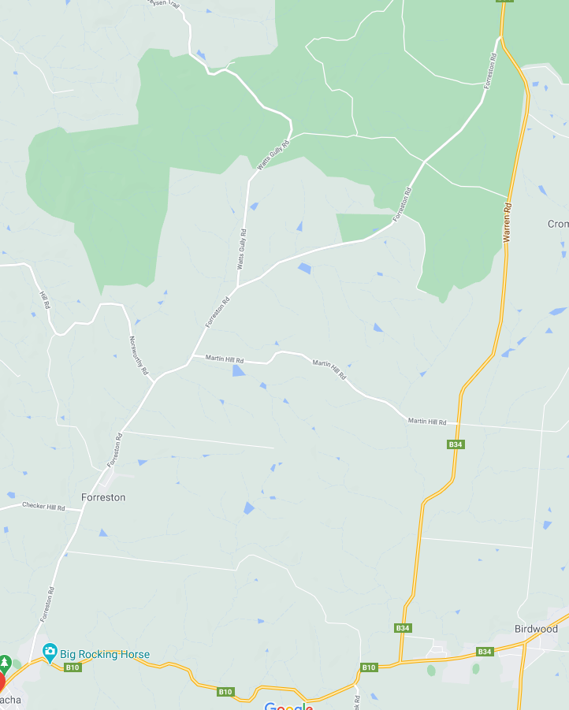
BIRDWOOD
ZONE 1: See detailed map below
GUMERACHA
FORRESTON
FORRESTON ROAD
MARTIN HILL ROAD
WARREN ROAD
FORRESTON ROAD
ZONE 3: See detailed map below
ZONE 5: See detailed map below
ZONE 4: See detailed map below
FINISH
START
ZONE 2: See detailed map below
50
80
80
80
80
80
100
50
80

ZONE 1: START AREA
ALL SIGNAGE IS PLACED WITHIN A STANDARD 50KM SPEED ZONE

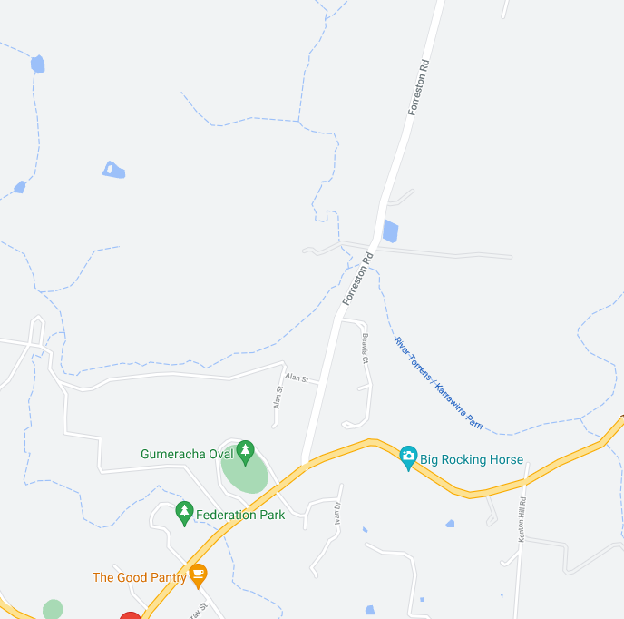
Event AHEAD
ALBERT STREET
GUMERACHA
START
Event AHEAD
FORRESTON RD
RANDELL TERRACE

ZONE 2: FORRESTON ROAD – MARTIN HILL ROAD INTERSECTION
ON FORRESTON RD ALL SIGNAGE IS PLACED WITHIN A STANDARD 100KM SPEED ZONE
ON MARTIN HILL RD ALL SIGNAGE IS PLACED WITHIN A STANDARD 80KM SPEED ZONE

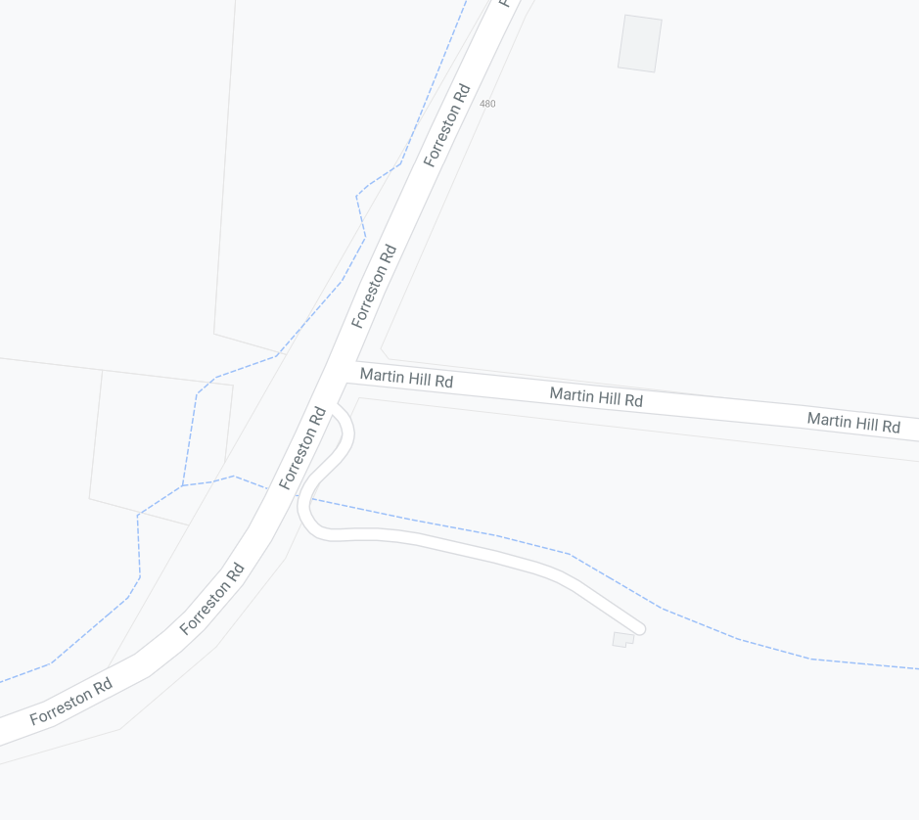
MULTI MESSAGE
Event bike
PREPARE TO STOP
SYMBOLIC CONTROLLER
SPEED RESTRICTION - 40
MARSHAL
EVENT AHEAD
MULTI MESSAGE
Event AHEAD
Event bike
Speed restriction ahead - 40
MULTI MESSAGE (X2)
PREPARED TO STOP
symbolic controller
Speed restriction – 40
Speed resumption – 100
END EVENT

MULTI MESSAGE (X2)
PREPARED TO STOP
SYMBOLLIC CONTROLLER
Speed restriction – 40
Speed resumption - 100

MARSHAL
MULTI MESSAGE
Event AHEAD
Event bike
Speed restriction ahead - 40
FORRESTON ROAD ROAD
FORRESTON ROAD ROAD
MARTIN HILL ROAD

ZONE 3: FINISH AREA (6.0 km from start point)
ALL SIGNAGE IS PLACED WITHIN A STANDARD 80KM SPEED ZONE

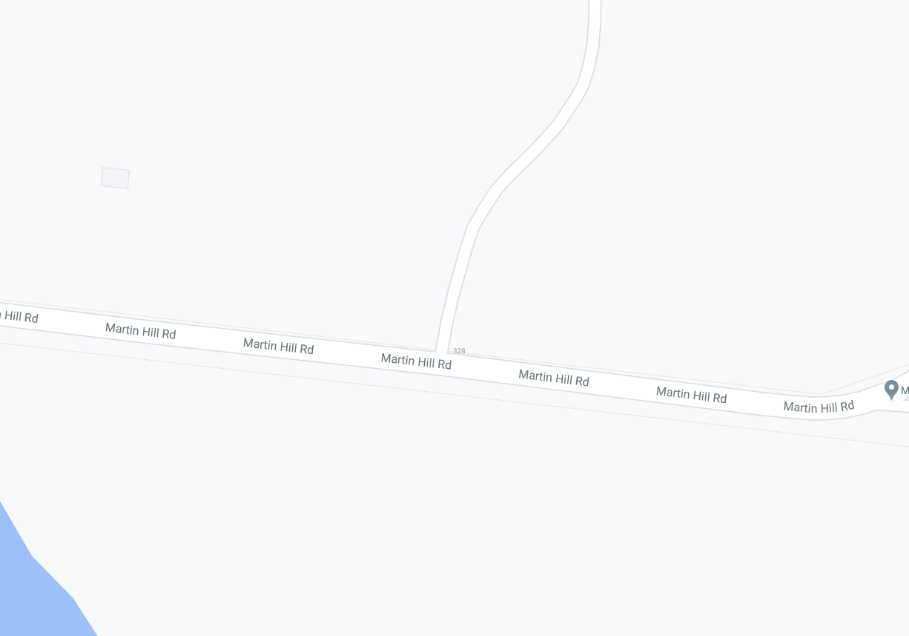
MULTI MESSAGE
PREPARE TO STOP
symbolic controller
Speed restriction - 60

MARSHAL
MARSHAL
MULTI MESSAGE (X2)
PREPARED TO STOP
symbollic controller
Speed restriction – 40
Speed resumption - 80

MULTI MESSAGE
Event AHEAD
Event bike
Speed restriction ahead - 40
MARTIN HILL ROAD
Finish

ZONE 4: MARTIN HILL RD – WARREN RD INTERSECTION
ALL SIGNAGE IS PLACED WITHIN A STANDARD 100KM SPEED ZONE

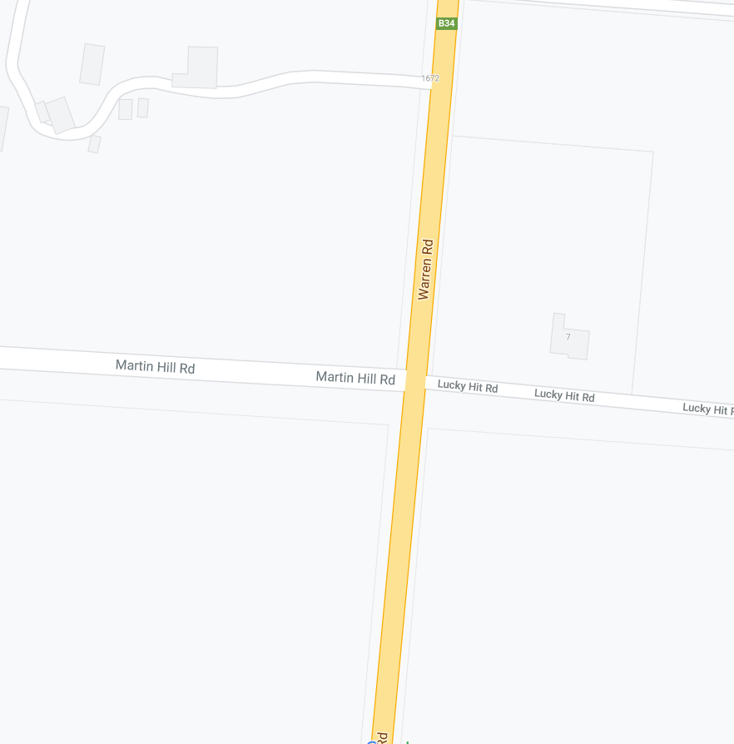
EVENT AHEAD
MULTI MESSAGE
Event AHEAD
Event bike
Speed restriction ahead - 40
MARSHAL
MULTI MESSAGE (X2)
PREPARED TO STOP
SYMBOLIC CONTROLLER
Speed restriction – 40
Speed resumption - 100

MULTI MESSAGE (X2)
PREPARED TO STOP
SYMBOLIC CONTROLLER
Speed restriction – 40
Speed resumption – 100
END EVENT

MULTI MESSAGE
Event AHEAD
Event bike
Speed restriction ahead - 40
MARSHAL
WARREN ROAD
WARREN ROAD
MARTIN HILL ROAD

ZONE 5: WARREN RD – FORRESTON RD INTERSECTION
ALL SIGNAGE IS PLACED WITHIN A STANDARD 100KM SPEED ZONE
SPEED RESUMPTION - 100
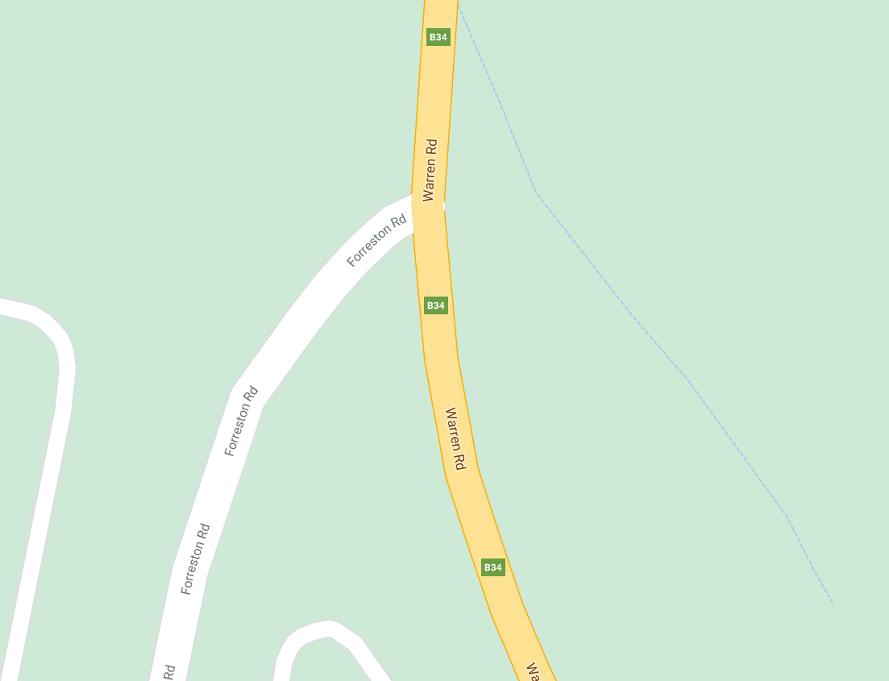
MULTI MESSAGE (X2)
PREPARED TO STOP
SYMBOLIC CONTROLLER
Speed restriction – 40
Speed resumption - 100

EVENT AHEAD
MARSHAL
MULTI MESSAGE
Event AHEAD
Event bike
Speed restriction ahead - 40
WARREN ROAD
FORRESTON ROAD ROAD

