ADELAIDE HILLS CYCLING CLUB – HARROGATE ROAD COURSE
Distances:
Harrogate Rd loop = 19.4 km
From Harrogate Rd loop end to top of Mail Rd = 7.1 km

HARROGATE
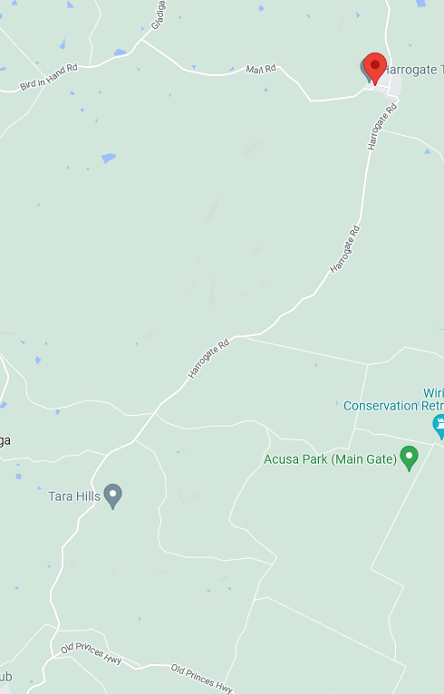
ZONE 3: See detailed map below
ZONE 2: See detailed map below
50
80
HARROGATE RD
80
OLD PRINCESS HWY
HARROGATE RD
DAWESLEY
ZONE 1: See detailed map below
START
50
MAIL ROAD
100
BIRD IN HAND ROAD
ZONE 4: See detailed map below
FINISH
ZONE 1: START AREA
ALL SIGNAGE IS PLACED WITHIN A STANDARD 50KM SPEED ZONE

MULTI MESSAGE (X2)
PREPARE TO STOP
SYMBOLIC CONTROLLER
SPEED RESTRICTION – 40
SPEED RESUMPTION – 50
Event AHEAD
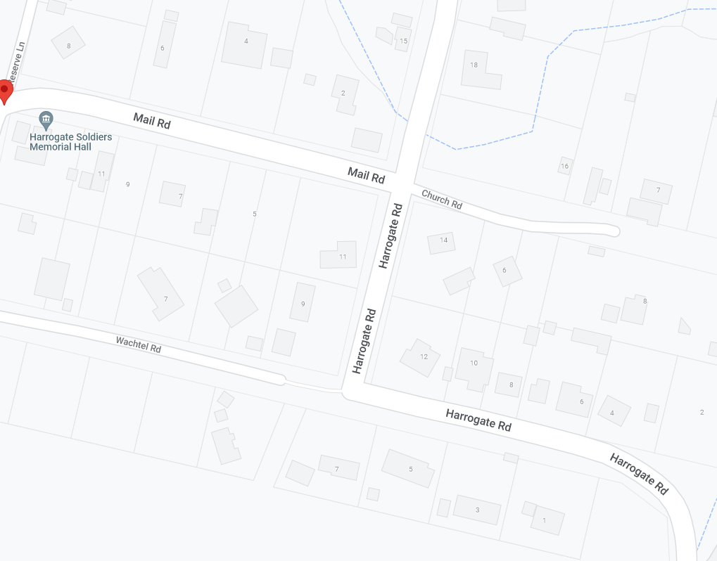
SPEED RESTRICTION – 40
SPEED RESTRICTION – 40
Event AHEAD
Event AHEAD
START
Marshal
HARROGATE RD
CHURCH RD
HARROGATE RD
MAIL RD
HARROGATE RD
HARROGATE
Event AHEAD
ZONE 2: HARROGATE RD – TURNAROUND POINT (NORTH-END)
ALL SIGNAGE IS PLACED WITHIN A STANDARD 80KM SPEED ZONE
MULTI MESSAGE
Event AHEAD
Event bike
Speed restriction ahead - 40
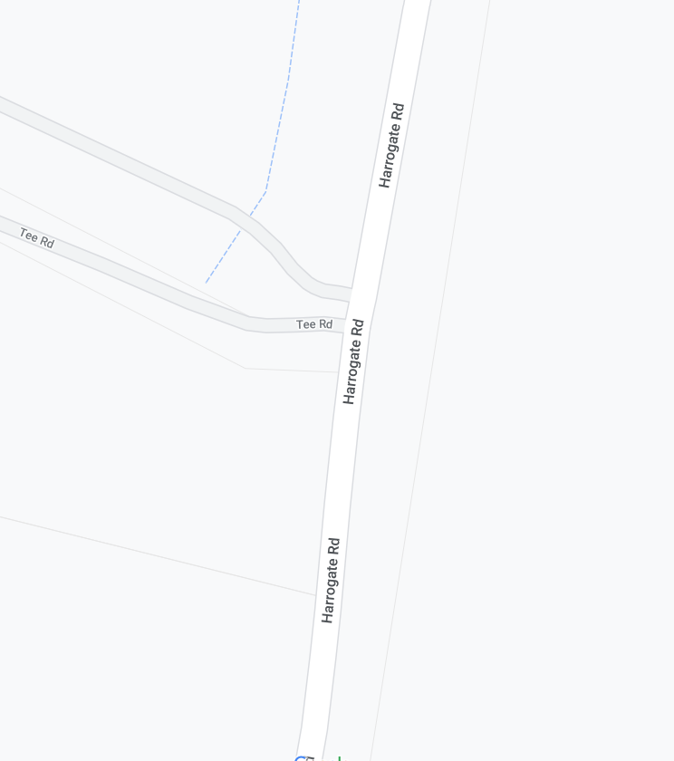
Event AHEAD
MULTI MESSAGE
Event AHEAD
Event bike
Speed restriction ahead - 40
RIDER U-TURN
MARSHAL
MULTI MESSAGE (X2)
PREPARED TO STOP
SYMBOLIC CONTROLLER
Speed restriction – 40
Speed resumption - 80

RIDER U-TURN
SAFETY CONES TO SHOW TURNAROUND POINT
TURNAROUND POINT
MARSHAL
MULTI MESSAG (X2)
PREPARE TO STOP
SYMBOLIC CONTROLLER
Speed restriction – 40
Speed resumption - 80

TEE RD
HARROGATE RD
ZONE 3: HARROGATE RD – TURNAROUND POINT (SOUTH-END)
ALL SIGNAGE IS PLACED WITHIN A STANDARD 80KM SPEED ZONE

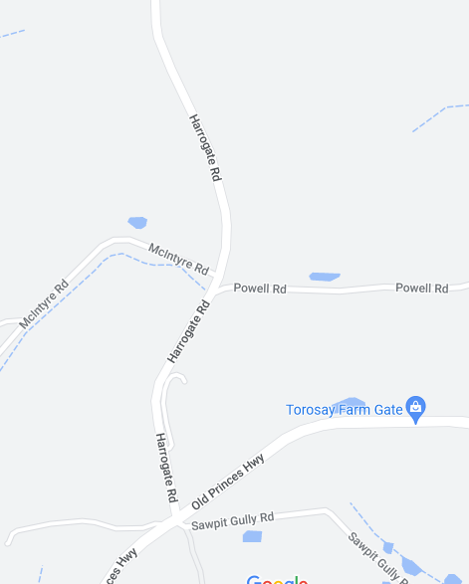
MCINTYRE RD
HARROGATE RD
MULTI MESSAGE
Event AHEAD
Event bike
Speed restriction ahead - 40
RIDER U-TURN
MARSHAL
MULTI MESSAGE (X2)
PREPARE TO STOP
SYMBOLIC CONTROLLER
SPEED RESTRICTION – 40
SPEED RESUMPTION – 80
POWELL RD
OLD PRINCESS HWY
TURNAROUND POINT
SAFETY CONES TO SHOW TURNAROUND POINT
MULTI MESSAGE
Event AHEAD
Event bike
Speed restriction ahead - 40
RIDER U-TURN
MULTI MESSAGE (X2)
PREPARE TO STOP
SYMBOLIC CONTROLLER
SPEED RESTRICTION – 40
SPEED RESUMPTION – 80
END EVENT

MARSHAL

ZONE 4: FINISH
ALL SIGNAGE IS PLACED WITHIN A STANDARD 100KM SPEED ZONE

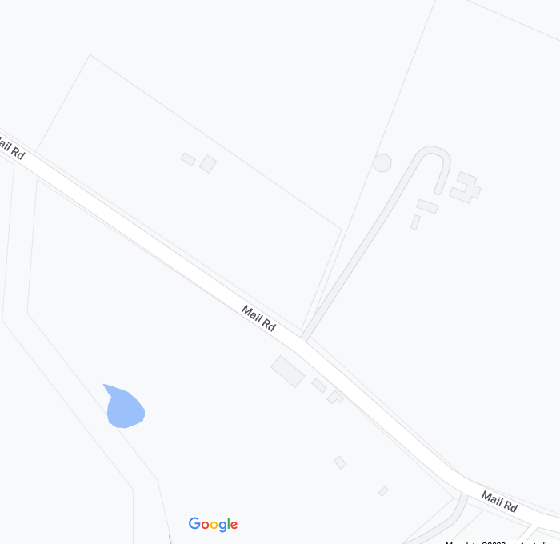
MULTI MESSAGE (X2)
PREPARE TO STOP
SYMBOLIC CONTROLLER
SPEED RESTRICTION – 40
SPEED RESUMPTION – 100
END EVENT
MULTI MESSAGE
Event AHEAD
Event bike
Speed restriction ahead - 40
MARSHAL
FINISH – 100M NORTH OF 389 MAIL RD
MAIL ROAD
MARSHAL
MULTI MESSAGE (X2)
PREPARE TO STOP
SYMBOLIC CONTROLLER
SPEED RESTRICTION – 40
SPEED RESUMPTION - 100
MULTI MESSAGE
Event AHEAD
Event bike
Speed restriction ahead - 40

ADDITIONAL ‘EVENT’ SIGNS ON HARROGATE RD

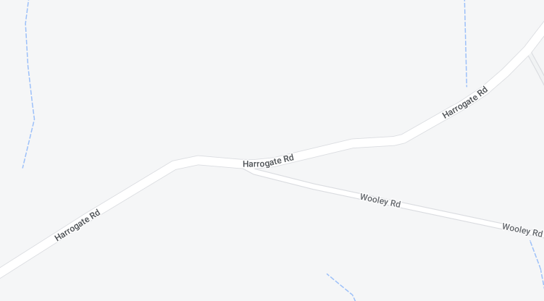
WOOLEY RD
HARROGATE RD
HARROGATE RD
Event AHEAD
Event AHEAD

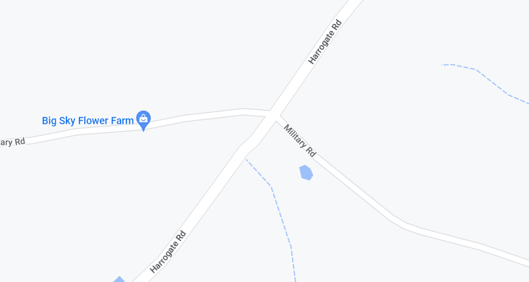
Event AHEAD
MILITARY RD
MILITARY RD
HARROGATE RD
HARROGATE RD
Event AHEAD

