 MT BARKER RD VELOWAY (‘KENNELS-TO-BLACKBURN’) HILLCLIMB SIGNAGE MAP

Distance: From start to finish point via Blackburn Drive = 7.6 km

START
At ‘The Kennels’, on the Tollgate to Bollards veloway
ZONE 1:
See detailed
map below
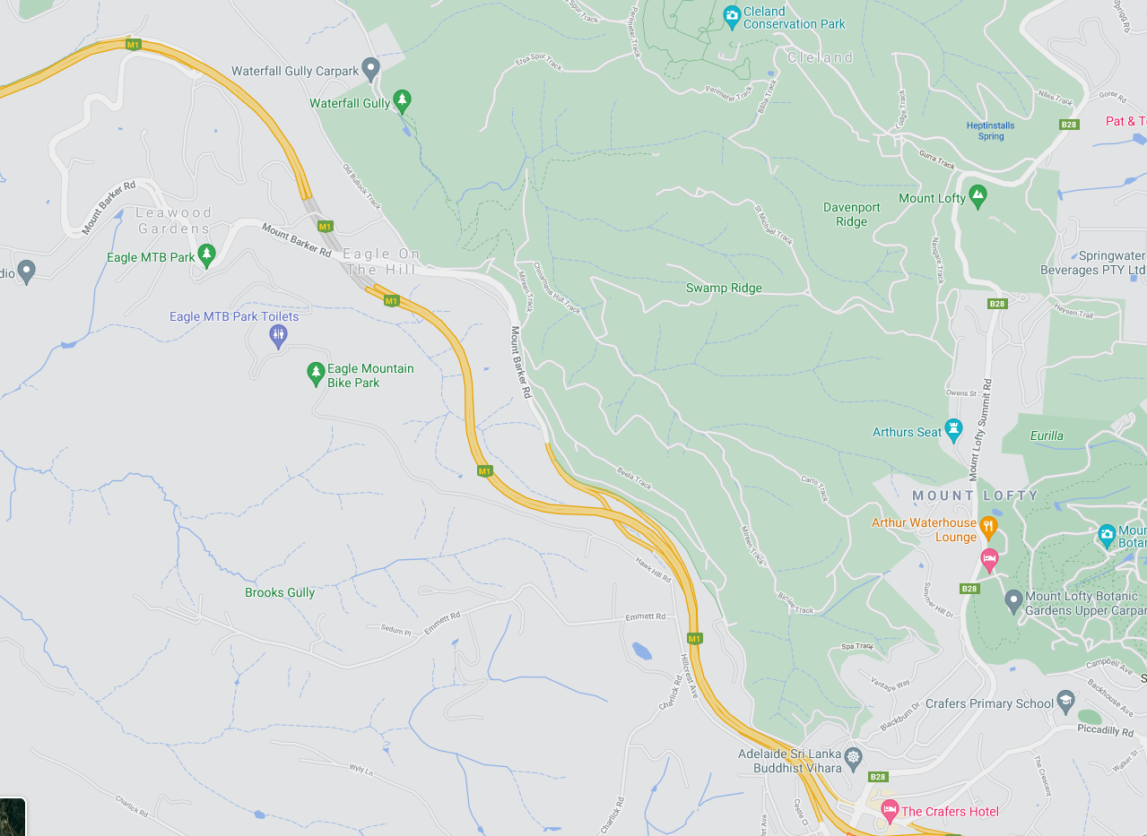
FINISH
Top of Blackburn Dr, Crafers
ZONE 2:
See detailed
map below
MOUNT LOFTY SUMMIT
MT BARKER RD VELOWAY
MT BARKER RD VELOWAY
CRAFERS
MT BARKER RD VELOWAY

ZONE 1: START AREA
ALL SIGNAGE IS PLACED IN A PARKING AREA ON THE MT BARKER RD VELOWAY

Start point: is in a parking area on the Mt Barker Rd veloway.
Riders follow the Mt Barker Rd Veloway

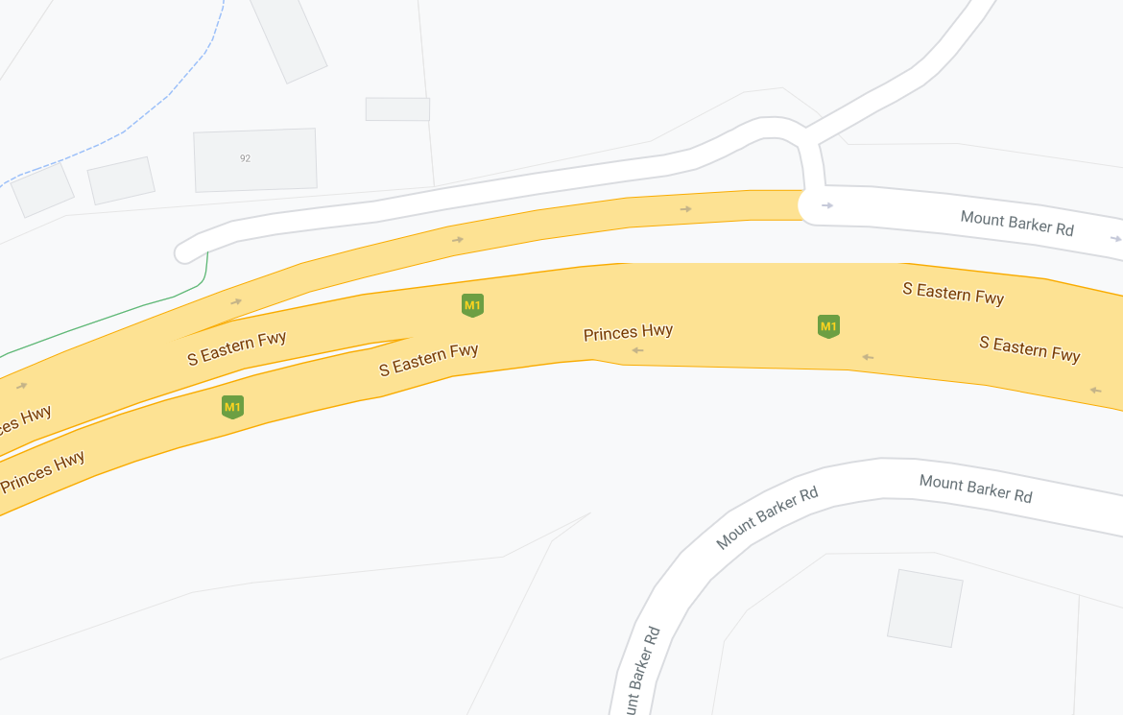
START
Event AHEAD
MT BARKER RD
MT BARKER RD VELOWAY
MT BARKER RD VELOWAY

ZONE 2: FINISH AREA
ALL SIGNAGE IS PLACED WITHIN A STANDARD 50KM SPEED ZONE

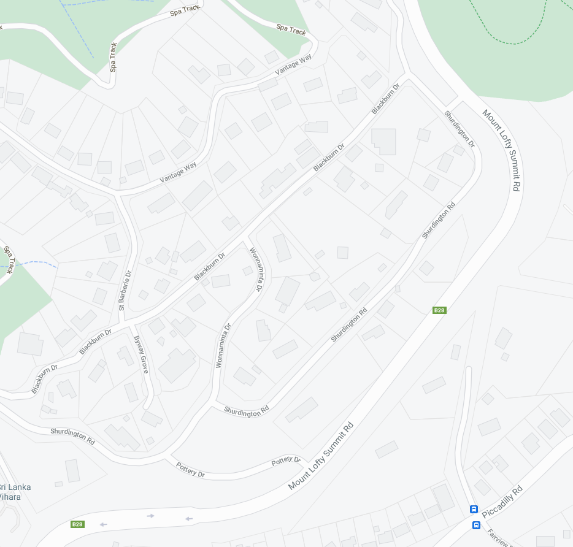
MULTI MESSAG (X1)
EVENT AHEAD
EVENT BIKE
Speed restriction – 40
Speed resumption – 50
end event
MULTI MESSAG (X1)
EVENT AHEAD
EVENT BIKE
Speed restriction – 40
Speed resumption – 50
end event
Finish
POTTERY DR
SHURDINGTON RD
WONNAMINTA DR
MOUNT LOFTY SUMMIT RD
SHURDINGTON RD
BLACKBURN DR

