 OAKWOOD ROAD SIGNAGE MAP
Distances:
Full loop = 8.9 km

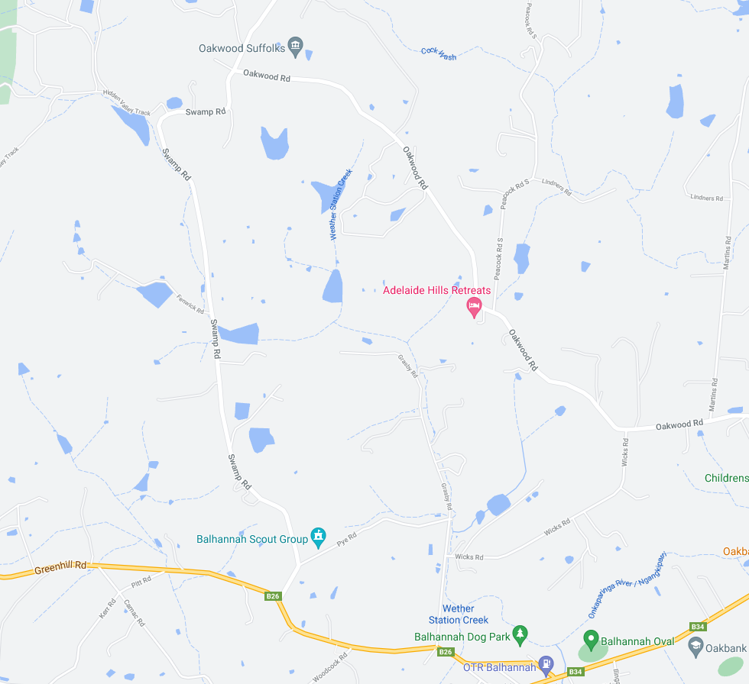
BALHANNAH
ZONE 4: See detailed map below
ZONE 3: See detailed map below
ZONE 2: See detailed map below
ZONE 1: See detailed map below
START
PYE ROAD
SWAMP ROAD
GRASBY ROAD
OAKWOOD ROAD
WICKS ROAD
GREENHILL ROAD ROAD
Finish

ZONE 1:
START AND FINISH AREAS
SWAMP RD AND GREENHILL RD INTERSECTION
MULTI MESSAGE
Event AHEAD
Event bike
Speed restriction ahead - 40
ALL SIGNAGE IS PLACED WITHIN A STANDARD 80KM SPEED ZONE

MULTI MESSAGE (X2)
PREPARED TO STOP
SYMBOLIC CONTROLLER
Speed restriction – 40
Speed resumption - 80

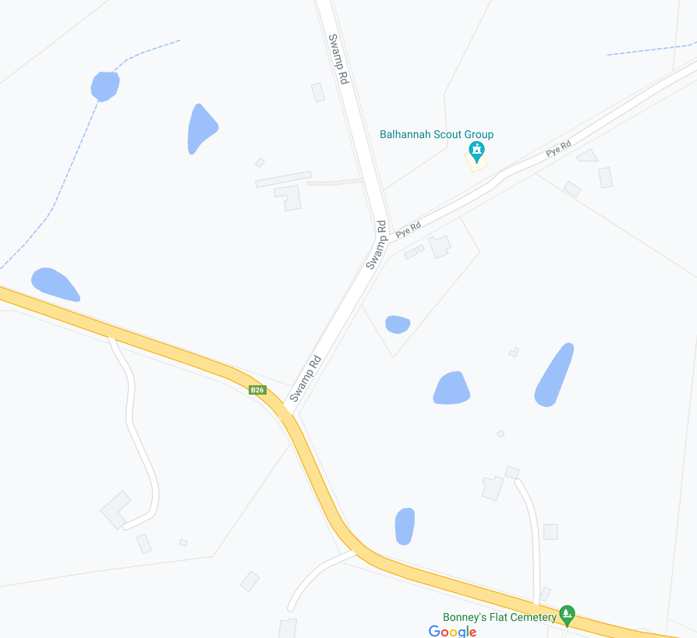
SAFETY CONES on edge of Swamp where edge is broken
PARKING CONTROL cones across driveways at 20 Pye Rd
SPEED RESUMPTION - 80
Finish
Start SPOTTER
MULTI MESSAGE
Event AHEAD
Event bike
Speed restriction ahead - 40
MULTI MESSAGE (X2)
PREPARED TO STOP
SYMBOLIC CONTROLLER
Speed restriction – 40
Speed resumption - 80

MARSHAL
MARSHAL
MULTI MESSAG (X2)
PREPARE TO STOP
SYMBOLIC CONTROLLER
Speed restriction – 40
SPEED RESUMPTION - 80
END EVENT

MULTI MESSAGE
Event AHEAD
Event bike
Speed restriction ahead - 40
MARSHAL
Speed Restriction - 40
START
PYE ROAD
SWAMP ROAD
GREENHILL ROAD ROAD
MARSHAL
ZONE 2:
GREENHILL RD AND GRASBY RD INTERSECTION
GRASBY RD AND WICKS RD INTERSECTION
ALL SIGNAGE IS PLACED WITHIN A STANDARD 80 KM SPEED ZONE

40 AHEAD
MULTI MESSAGE)
PREPARED TO STOP
SYMBOLIC CONTROLLER
Speed restriction – 40
Speed resumption – 80
end event

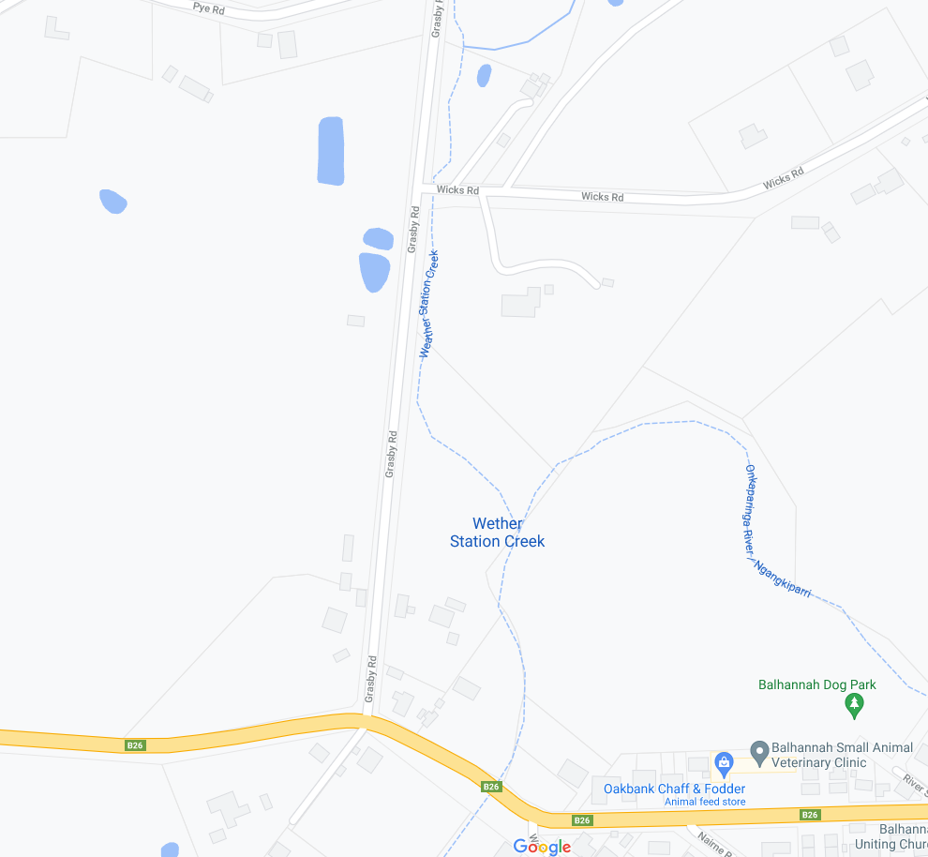
Speed Restriction - 40
SPEED RESUMPTION - 80
Speed Restriction - 40
END EVENT
Marshal
SPOTTER
MARSHAL
GREENHILL ROAD
GREENHILL ROAD
GRASBY ROAD
GRASBY ROAD
WICKS ROAD

ZONE 3: WICKS RD AND OAKWOOD RD INTERSECTION
ALL SIGNAGE IS PLACED WITHIN A STANDARD 80KM SPEED ZONE

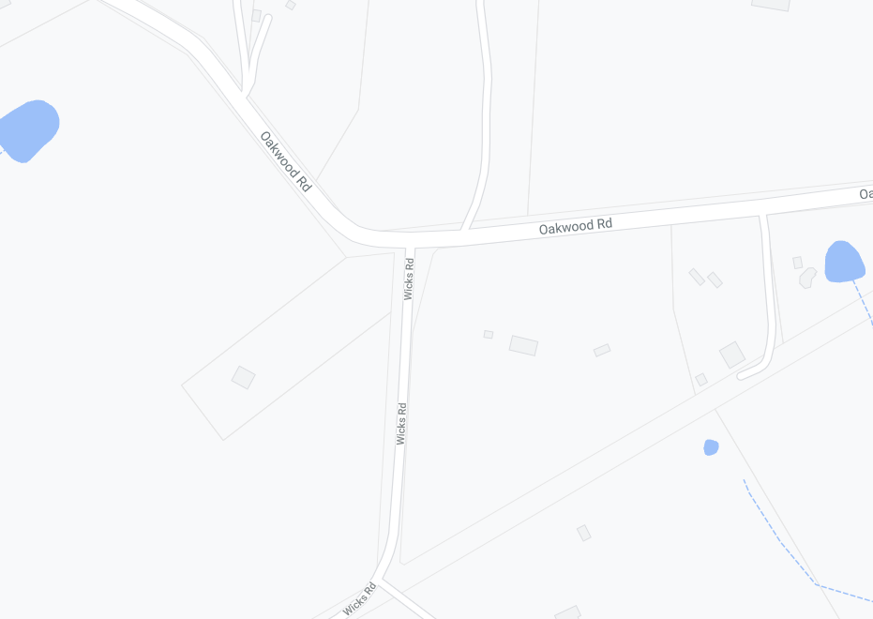
MULTI MESSAGE
Event AHEAD
Event bike
Speed restriction ahead - 40
MARSHAL
MULTI MESSAGE (X2)
PREPARED TO STOP
SYMBOLIC CONTROLLER
Speed restriction – 40
Speed resumption – 80
END EVENT

Event AHEAD
SAFETY CONES
Speed Restriction - 50
SPEED RESUMPTION - 80
MULTI MESSAGE
Event AHEAD
Event bike
Speed restriction ahead - 40
WICKS ROAD
OAKWOOD ROAD
OAKWOOD ROAD

ZONE 4: OAKWOOD RD AND SWAMP RD INTERSECTION
ALL SIGNAGE IS PLACED WITHIN A STANDARD 80 KM SPEED ZONE
MULTI MESSAGE
Event AHEAD
Event bike
Speed restriction ahead - 40
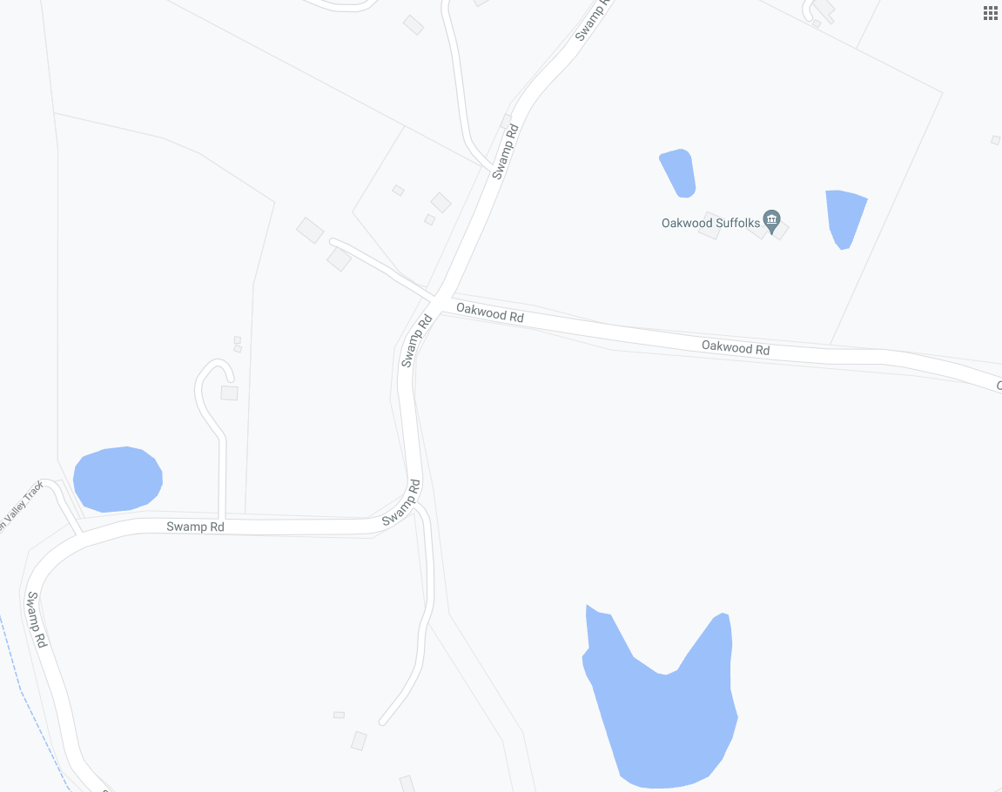
SPOTTER
OAKWOOD ROAD
MULTI MESSAGE (X2)
PREPARED TO STOP
SYMBOLIC CONTROLLER
Speed restriction – 40
Speed resumption - 80

MULTI MESSAGE
Event AHEAD
Event bike
Speed restriction ahead - 40
MULTI MESSAGE (X2)
PREPARED TO STOP
SYMBOLIC CONTROLLER
Speed restriction - 40
Speed resumption – 80
END EVENT
MARSHAL
SAFETY CONES
MARSHAL
SWAMP ROAD
SWAMP ROAD

