ADELAIDE HILLS CYCLING CLUB – SPRINGHEAD ROAD COURSE
Distances:
From start to finish point: 8.4 km
Full loop from finish point: 9.7 km

ZONE 1a: See detailed map below
START
80
50
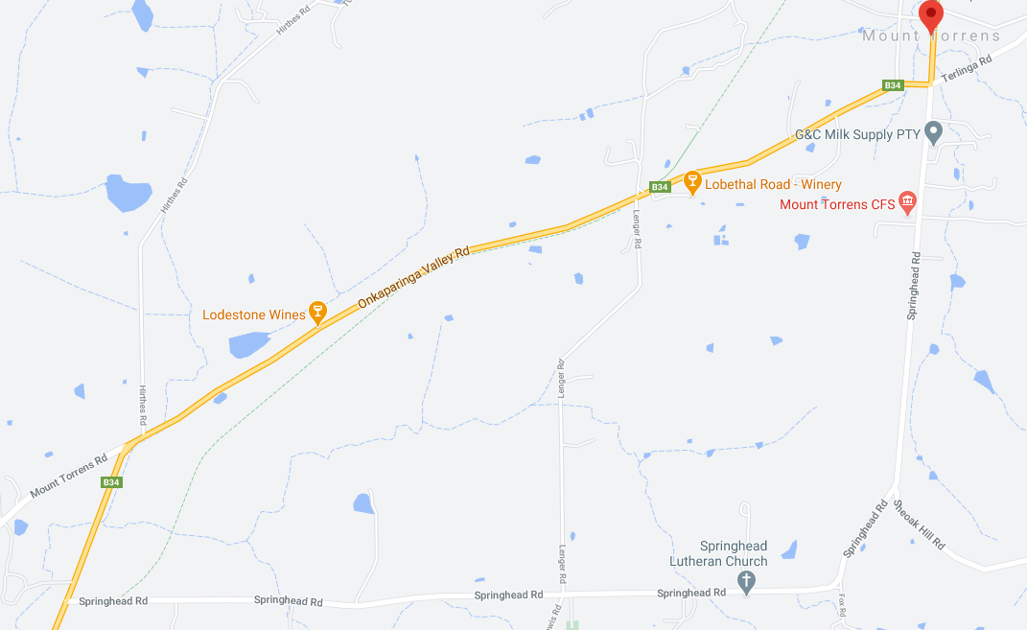
ZONE 1b: See detailed map below
100
ZONE 4: See detailed map below
ZONE 3: See detailed map below
ZONE 5: See detailed map below
ZONE 2: See detailed map below
FINISH
ONKAPARINGA VALLEY RD
ONKAPARINGA VALLEY RD
SHEOAK HILL RD
50
TERLINGA RD
SPRINGHEAD ROAD
SPRINGHEAD ROAD
100
80
80
50
80
50
MT TORRENS

ZONE 1a: START AREA AND ONKAPARINGA/TOWNSEND/SPRINGHEAD/TERLINGA RDS INTERSECTION
SIGNAGE IS PLACED WITHIN BOTH 80KM AND 50KM SPEED ZONE

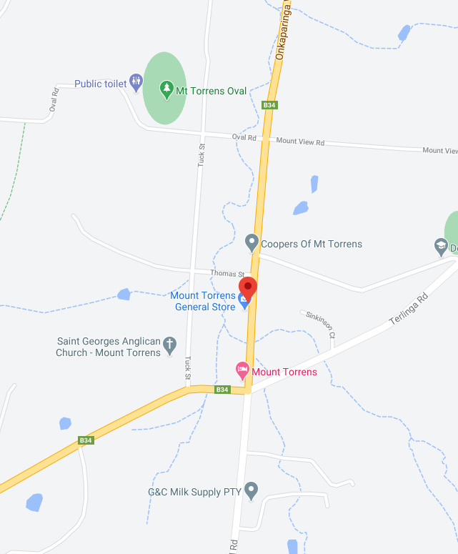
Event AHEAD
Speed Restriction - 40
100
100KM SIGN COVERED
50
Speed Restriction - 60
MULTI MEASSAGE (X2)
Prepare to stop
SYMBOLIC CONTROLLER
Speed Restriction – 40
Speed Resumption - 50
MULTI MESSAGE
Event AHEAD
Event bike
Speed restriction ahead - 40
MULTI MEASSAGE (X2)
Prepare to stop
SYMBOLIC CONTROLLER
Speed Restriction – 40
Speed Resumption – 50
END EVENT
Marshal
Marshal
MULTI MEASSAGE (X2)
Prepare to stop
SYMBOLIC CONTROLLER
Speed Restriction – 40
SPEED RESTRICTION - 60
MT TORRENS
MULTI MESSAGE
Event AHEAD
Event bike
Speed restriction ahead - 40
SAFETY CONES
TERLINGA ROAD
Marshal
Event AHEAD
ONKAPARINGA VALLEY RD
TOWNSEND ST
SPRINGHEAD ROAD
START
MOUNT VIEW ROAD
ONKAPARINGA VALLEY RD

ZONE 1b: ONKAPARINGA VALLEY RD – UPHILL SECTION HEADING WEST FROM MT TORRENS

SIGNS FOR WEST BOUND TRAFFIC ARE REMINDERS OF THE 40KM SPEED RESTRICTION, UNTIL THE 100KM ZONE IS REINSTATED

MT TORRENS
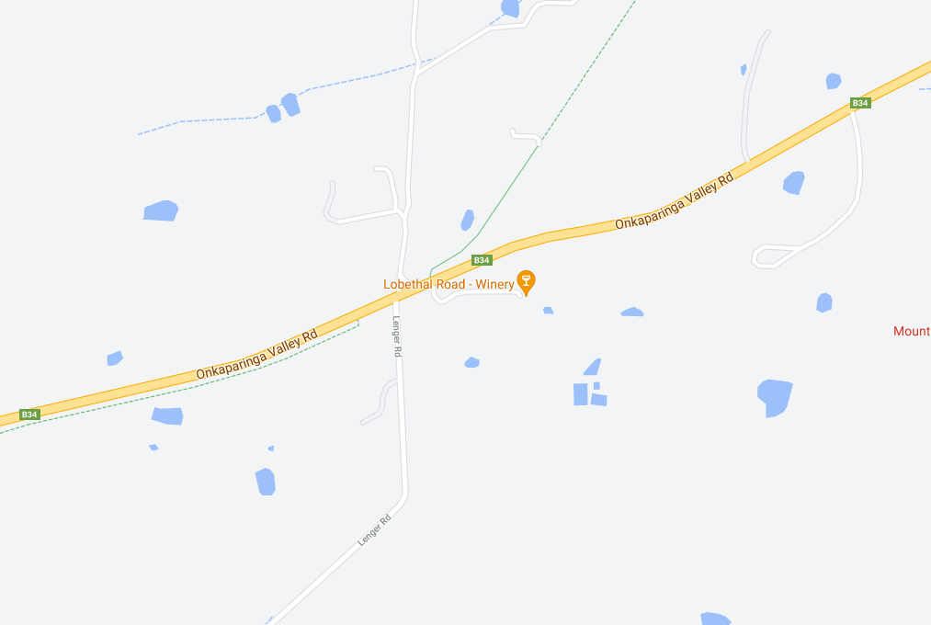
SPEED RESUMPTION - 100
SPEED RESUMPTION - 80
LENGER RD
Speed Restriction - 80
Event AHEAD
Speed Restriction - 60

ZONE 2: ONKAPARINGA VALLEY ROAD LEFT TURN
ALL SIGNAGE IS PLACED WITHIN A STANDARD 100KM SPEED ZONE

NOTE: CYCLISTS HAVE RIGHT-OF-WAY ON THE LEFT TURN ON ONKAPARINGA ROAD.

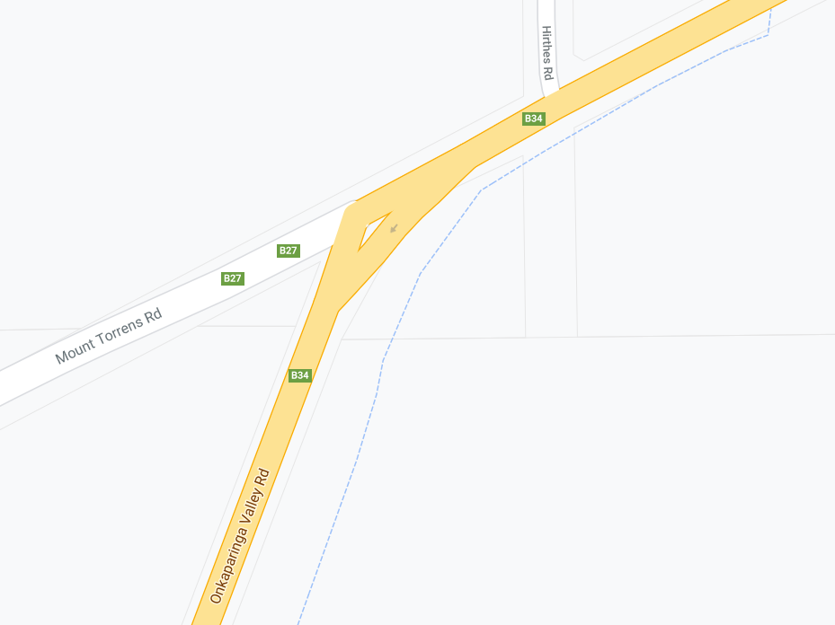
Event AHEAD
SPEED RESUMPTION - 100
SAFETY CONES
ONKARPARINGA VALLEY RD
ONKARPARINGA VALLEY RD
MOUNT TORRENS RD

ZONE 3: ONKAPARINGA VALLEY ROAD LEFT TURN ONTO SPRINGHEAD ROAD
ALL SIGNAGE IS PLACED WITHIN A STANDARD 100KM SPEED ZONE

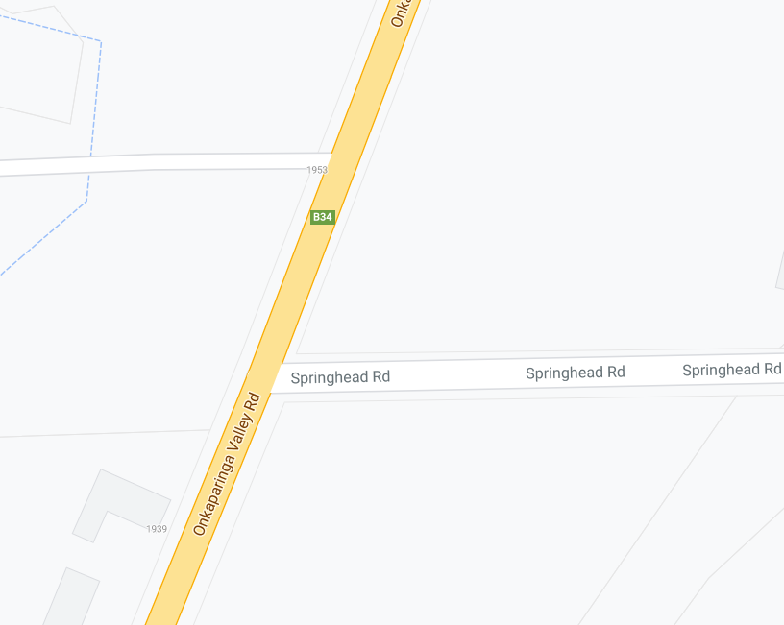
Speed Restriction - 40
BRIDGE – NARROW ROAD
Event AHEAD
Speed Restriction - 80
Speed Restriction - 60
MARSHAL
MULTI MESSAGE (X2)
PREPARE TO STOP
SYMBOLIC CONTROLLER
SPEED RESTRICTION – 40
SPEED RESUMPTION - 100
SPEED RESUMPTION - 100
ONKARPARINGA VALLEY RD
SAFETY CONES
SPRINGHEAD ROAD
MULTI MESSAGE
Event AHEAD
Event bike
Speed restriction ahead - 40

ZONE 4: SPRINGHEAD RD, LENGER RD & LEWIS RD INTERSECTION
ALL SIGNAGE IS PLACED WITHIN A STANDARD 100KM SPEED ZONE

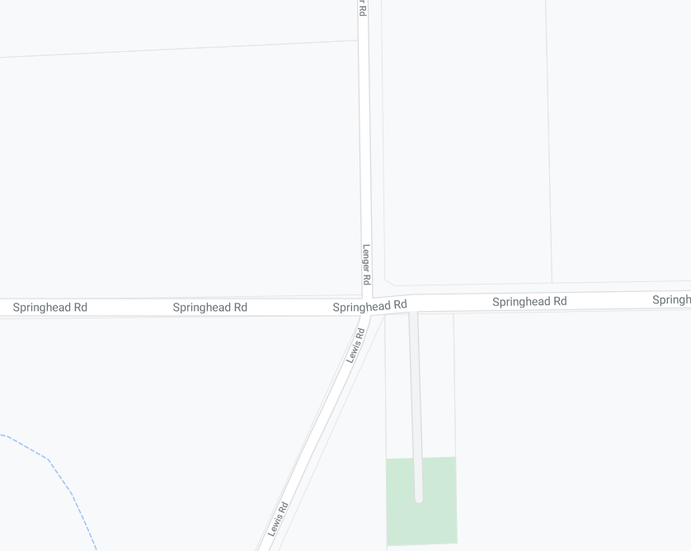
SPRINGHEAD ROAD
LEWIS RD
LENGER RD
SPRINGHEAD ROAD
Event AHEAD
Event AHEAD

ZONE 5: FINISH AREA
ALL SIGNAGE IS PLACED WITHIN A STANDARD 80KM SPEED ZONE

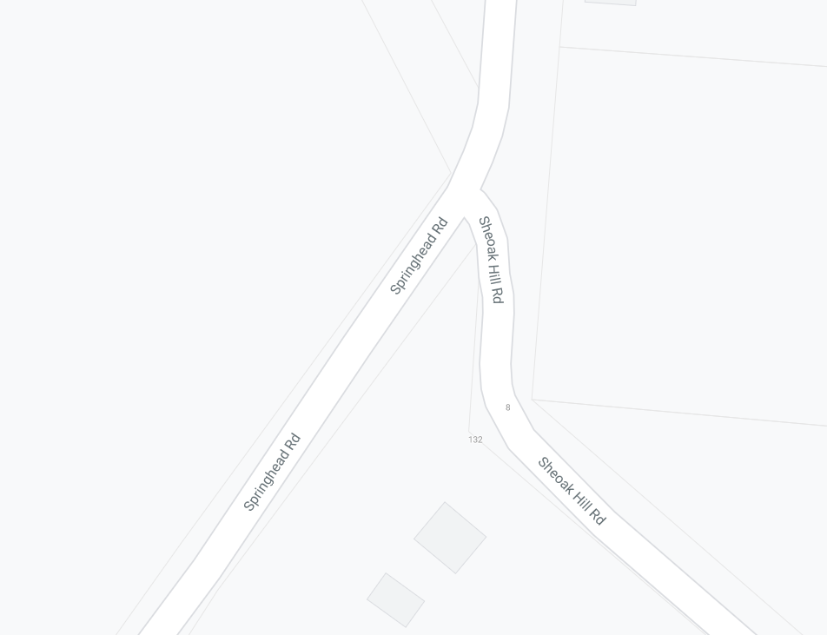
MARSHAL
MULTI MESSAGE (X2)
PREPARE TO STOP
SYMBOLIC CONTROLLER
Speed restriction – 40
Speed resumption - 80

MULTI MESSAGE (X2)
PREPARED TO STOP
SYMBOLIC CONTROLLER
Speed restriction – 40
Speed resumption - 80

MARSHAL
MULTI MESSAGE
Event AHEAD
Event bike
Speed restriction ahead - 40
MULTI MESSAGE
Event AHEAD
Event bike
Speed restriction ahead - 40
Finish
Event AHEAD
SHEOAK HILL RD
SPRINGHEAD ROAD
SPRINGHEAD ROAD

