ADELAIDE HILLS CYCLING CLUB – STAMPS ROAD COURSE
Distances:
From start to finish point: 3.3km
Full loop from finish point: 12.9km

80
60
80
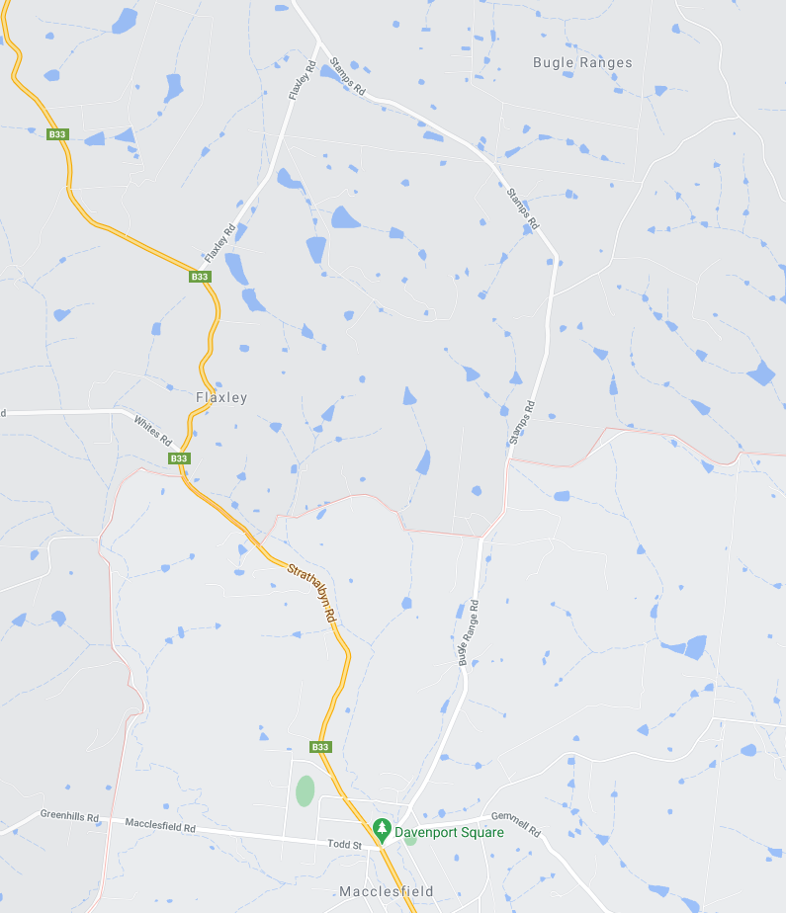
ZONE 4: See detailed map below
ZONE 3: See detailed map below

ZONE 1: See detailed map below
ZONE 2: See detailed map below
60
FLAXLEY ROAD
STAMPS ROAD
START
STRATHALBYN ROAD
FLAXLEY
MACCLESFIELD
50
80
80
80
50
50
80
60
60
FINISH

ZONE 1: START AREA
ALL SIGNAGE IS PLACED WITHIN A STANDARD 50KM SPEED ZONE

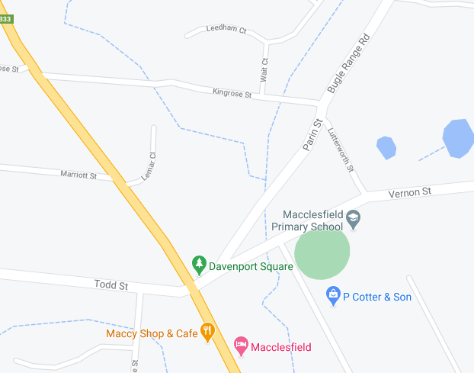
MARSHAL
MULTI MESSAGE (X1)
PREPARE TO STOP
STMBOLIC CONTROLLER
SPEED RESTRICTION – 40
SPEED RESUMPTION – 50
END EVENT
VERNON ST
PARIN ST
SAFETY CONES
MULTI MESSAGE (X1)
Prepare to stop
symbolic controller
Speed Restriction – 40
Speed Resumption - 50
Marshal
MULTI MESSAGE (X1)
Prepare to stop
SYMBOLIC CONTROLLER
Speed Restriction – 40
Speed Resumption - 50
SPOTTER
Event AHEAD
Event AHEAD
MACCLESFIELD
Event AHEAD
START
TODD ST
STRATHALBYN ROAD
BUGLE RANGE ROAD

ZONE 2: FINISH AREA (3.3 km from start point)
ALL SIGNAGE IS PLACED WITHIN A STANDARD 80KM SPEED ZONE

MULTI MESSAGE
Event AHEAD
Event bike
Speed restriction ahead - 40
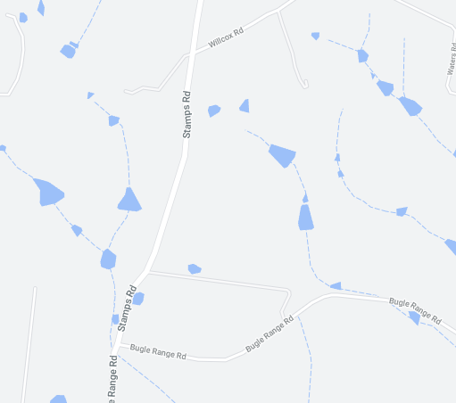
MULTI MESSAGE (X2)
PREPARED TO STOP
SYMBOLIC CONTROLLER
Speed restriction – 40
Speed resumption - 80

MULTI MESSAGE
Event AHEAD
Event bike
Speed restriction ahead - 40
MULTI MESSAG (X2)
PREPARE TO STOP
SYMBOLIC CONTROLLER
Speed restriction – 40
Speed resumption - 80

MARSHAL
MARSHAL
STAMPS ROAD
Finish

ZONE 3: STAMPS RD – FLAXLEY ROAD INTERSECTION
ALL SIGNAGE IS PLACED WITHIN A STANDARD 80KM SPEED ZONE

MULTI MESSAGE
Event AHEAD
Event bike
Speed restriction ahead - 40

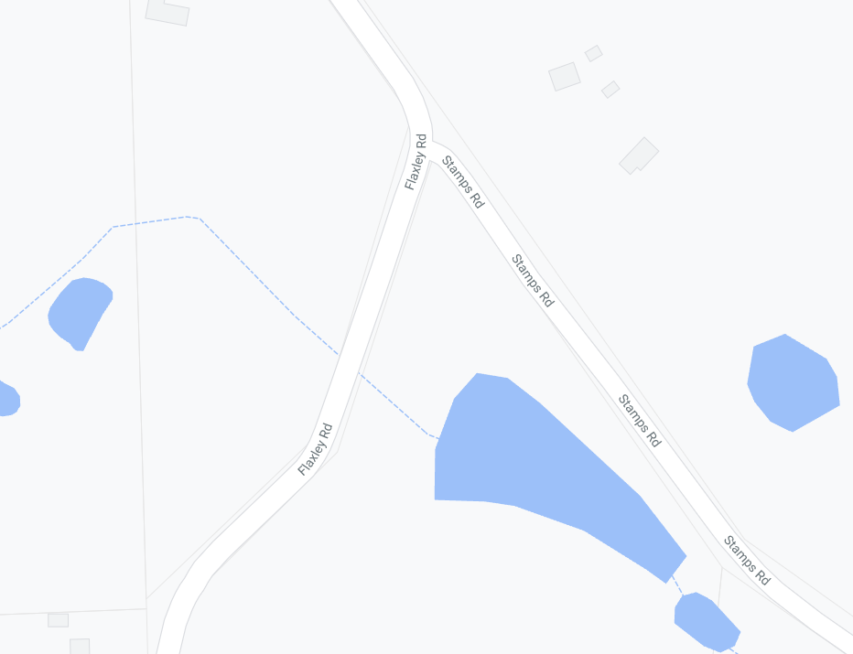
MULTI MESSAGE
Event AHEAD
Event bike
Speed restriction ahead - 40
MULTI MESSAGE (X2)
PREPARE TO STOP
SYMBOLIC CONTROLLER
SPEED RESTRICTION – 40
SPEED RESUMPTION - 80
MARSHAL
MULTI MESSAGE (X2)
PREPARE TO STOP
SYMBOLIC CONTROLLER
SPEED RESTRICTION – 40
SPEED RESUMPTION – 80
END EVENT
FLAXLEY ROAD
STAMPS ROAD
MARSHAL

ZONE 4: FLAXLEY RD - STRATHALBYN ROAD INTERSECTION
ALL SIGNAGE IS PLACED WITHIN A STANDARD 60KM SPEED ZONE

Event AHEAD
MULTI MESSAGE (X2)
PREPARE TO STOP
SYMBOLIC CONTROLLER
SPEED RESTRICTION – 40
SPEED RESUMPTION – 60
END EVENT

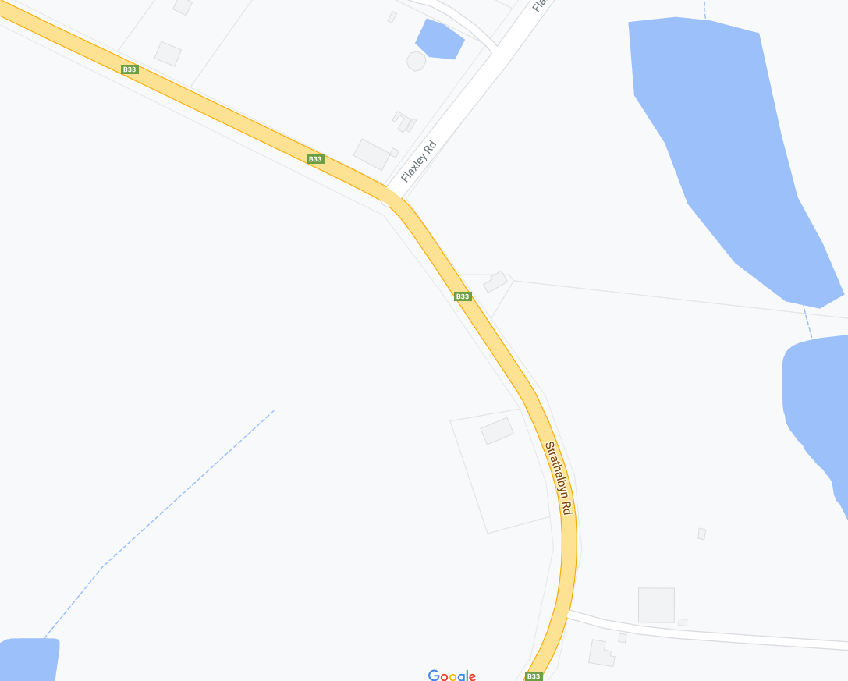
Event AHEAD
SAFETY CONES
SPEED RESUMPTION - 80
FLAXLEY ROAD
STRATHALBYN ROAD
FLAXLEY
STRATHALBYN ROAD
MARSHAL

