ADELAIDE HILLS CYCLING CLUB – TERLINGA ROAD COURSE
Distances:
- Full loop: Start point, out and back to finish point = 21.9 km:
- Shorter loops: Turnaround point 1 to turnaround point 2 and back again = 18.8 km
- Turnaround point 1 to finish = 1.5 km

TUNGKILLO
RANDELL RD
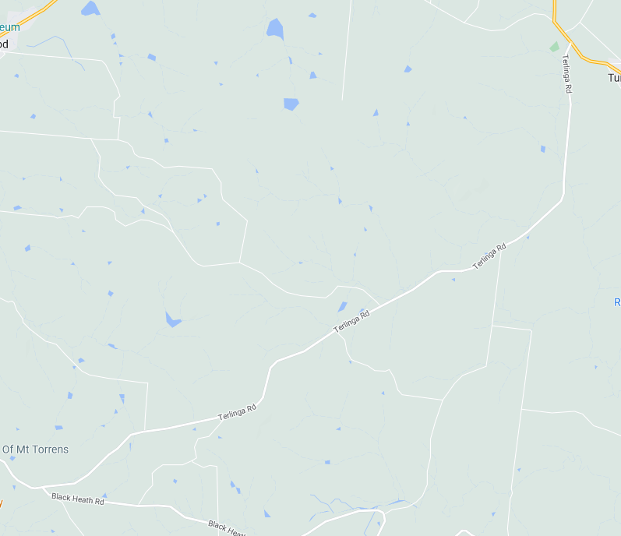
ZONE 2: See detailed map below
TURNAROUND POINT 1
TURNAROUND POINT 2
ZONE 3: See detailed map below
ZONE 1: See detailed map below
FINISH
80
100
BLACK HEATH RD
START
MT TORRENS
TERLINGA RD
ZONE 1: START AND FINISH AREAS
ALL SIGNAGE IS PLACED WITHIN A STANDARD 80KM AND 100KPH SPEED ZONE

MULTI MESSAGE
Event AHEAD
Event bike
Speed restriction ahead - 40

MULTI MESSAGE (X2)
PREPARE TO STOP
SYMBOLIC CONTROLLER
SPEED RESTRICTION – 40
SPEED RESUMPTION – 80
END EVENT

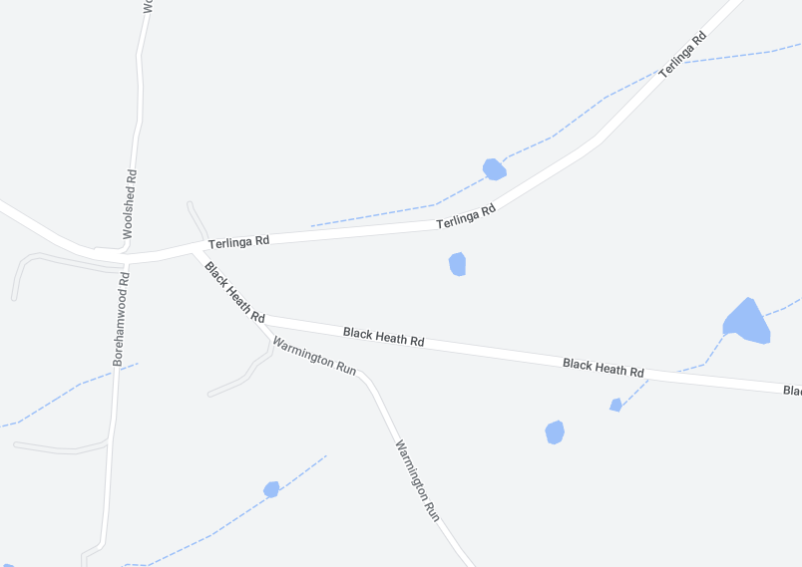
Event AHEAD
SPEED RESTRICTION – 40
FINISH (200M from the finish
START
MULTI MESSAGE
Event AHEAD
Event bike
Speed restriction ahead - 40
MULTI MESSAGE (X2)
PREPARE TO STOP
SYMBOLIC CONTROLLER
SPEED RESTRICTION – 40
SPEED RESUMPTION – 100
BLACK HEATH RD
MT TORRENS
TERLINGA RD

ZONE 2: TERLINGA RD – TURNAROUND POINT 1
ALL SIGNAGE IS PLACED WITHIN A STANDARD 100KM SPEED ZONE

MULTI MESSAGE
Event AHEAD
Event bike
Speed restriction ahead - 40
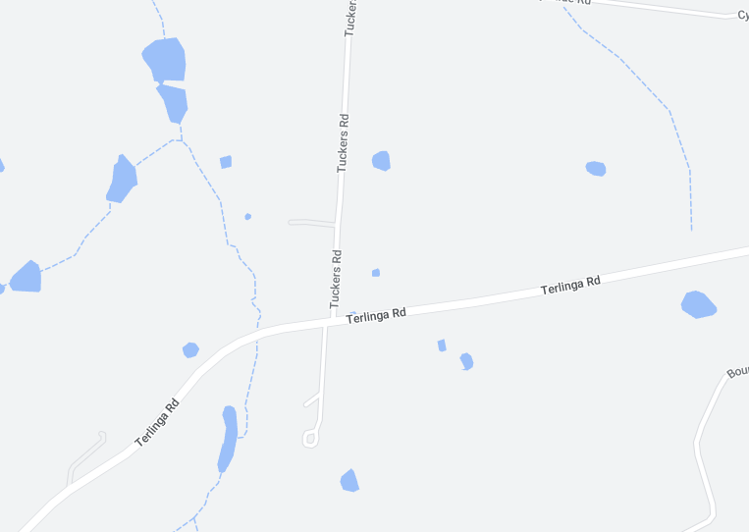
TERLINGA RD
MULTI MESSAG (X2)
PREPARE TO STOP
SYMBOLIC CONTROLLER
Speed restriction – 40
Speed resumption - 100

MARSHAL
MULTI MESSAGE
Event AHEAD
Event bike
Speed restriction ahead - 40
RIDER U-TURN
TERLINGA RD
TURNAROUND POINT
SAFETY CONES TO SHOW TURNAROUND POINT
TUCKERS RD
RIDER U-TURN
MARSHAL
MULTI MESSAGE (X2)
PREPARED TO STOP
SYMBOLIC CONTROLLER
Speed restriction – 40
Speed resumption – 100
END EVENT

Event AHEAD

ZONE 3: TERLINGA RD – TURNAROUND POINT 2
ALL SIGNAGE IS PLACED WITHIN A STANDARD 100KM SPEED ZONE

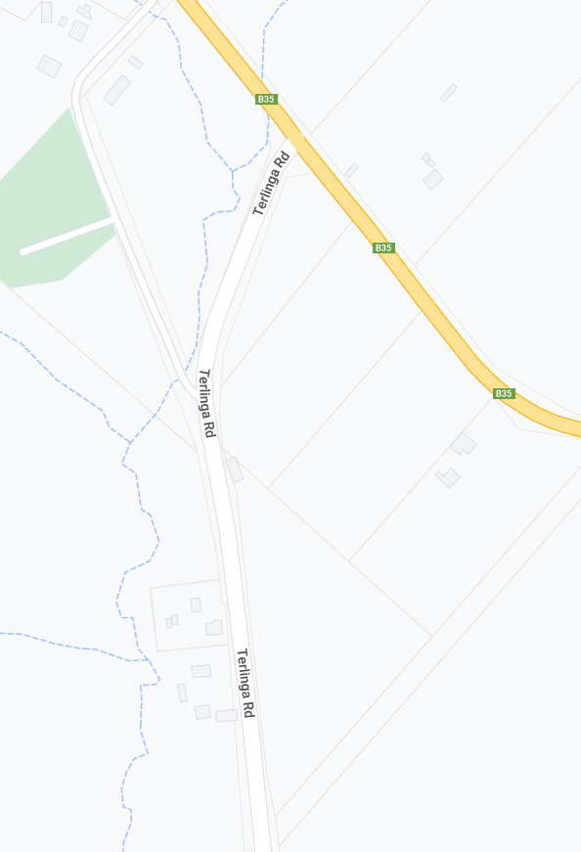
MULTI MESSAGE
Event AHEAD
Event bike
Speed restriction ahead - 40
RIDER U-TURN
MARSHAL
MULTI MESSAGE (X2)
PREPARED TO STOP
SYMBOLIC CONTROLLER
Speed restriction – 40
Speed resumption – 100
END EVENT

MULTI MESSAGE
Event AHEAD
Event bike
Speed restriction ahead - 40
RIDER U-TURN
MULTI MESSAG (X2)
PREPARE TO STOP
SYMBOLIC CONTROLLER
Speed restriction – 40
Speed resumption - 100

MARSHAL
RANDELL RD
TURNAROUND POINT
SAFETY CONES TO SHOW TURNAROUND POINT
TERLINGA RD
ADDITIONAL ‘EVENT’ SIGNS ON TERLINGA RD

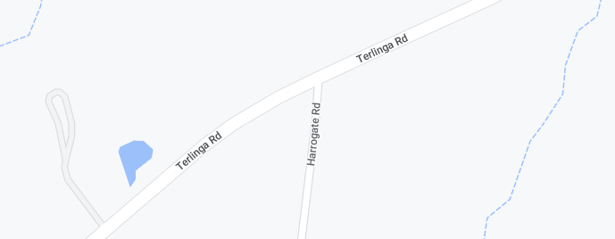
Event AHEAD
TERLINGA RD
HARROGATE RD
Event AHEAD
Event AHEAD
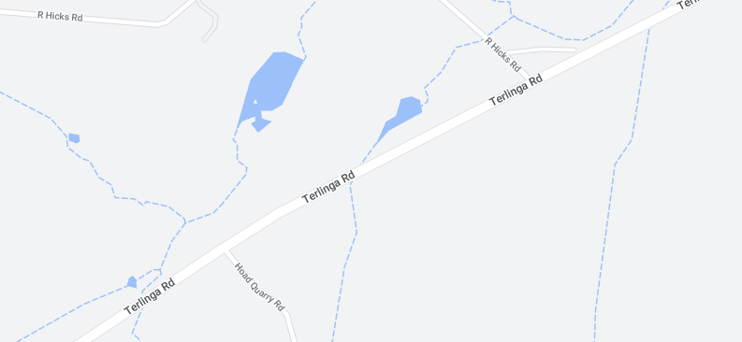
Event AHEAD
HOAD QUARRY RD
R.HICKS RD
TERLINGA RD

