 BRADBURY KERMESSE COURSE
Distances:
From start to finish point = 0.9 km
Full loop – 5.8 km

ZONE 2: See detailed map below
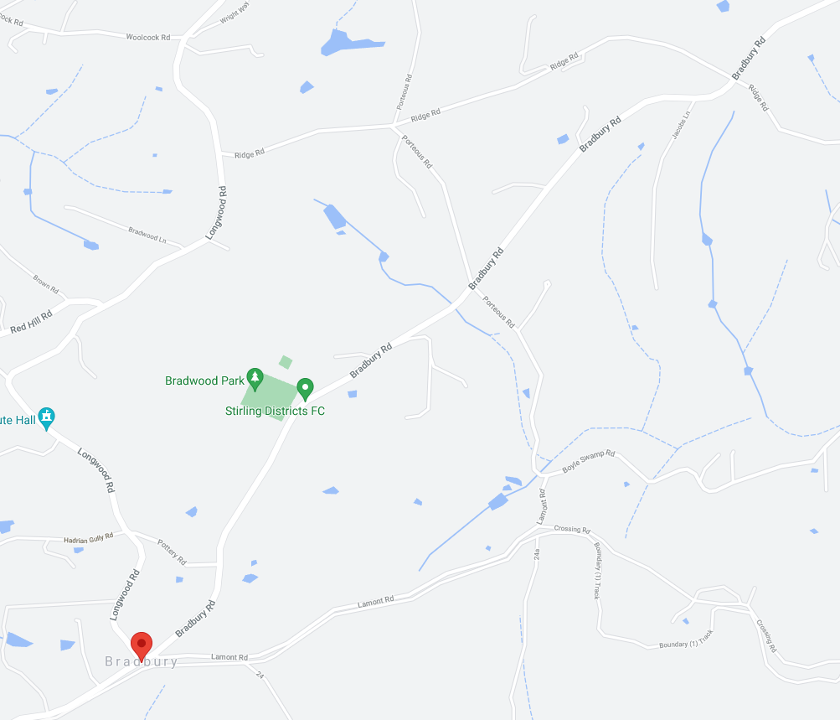
ZONE 1: See detailed map below
80
80
80
ZONE 4: See detailed map below
ZONE 3: See detailed map below
BRADBURY
80
60
60
60
80
80
80
80
80
LONGWOOD ROAD ROAD
RIDGE ROAD ROAD
BRADBURY ROAD ROAD
FINISH
START

ZONE 1: START AND FINISH AREAS
ALL SIGNAGE IS PLACED WITHIN A STANDARD 80KM SPEED ZONE

MULTI MESSAGE
Event AHEAD
Event bike
Speed restriction ahead - 40

MULTI MESSAGE (X2)
PREPARED TO STOP
SYMBOLIC CONTROLLER
Speed restriction – 40
Speed resumption - 80

MARSHAL
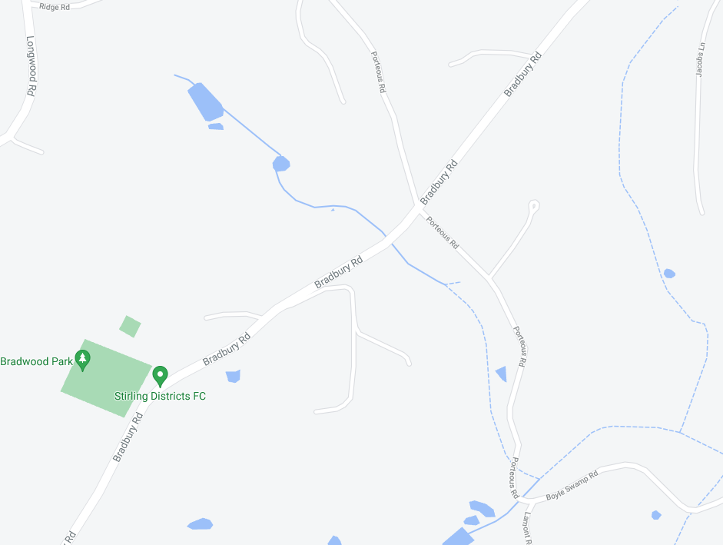
MARSHAL
MULTI MESSAGE (X2)
PREPARE TO STOP
Symbolic CONTROLLER
Speed restriction – 40
Speed resumption - 80

MULTI MESSAGE
Event AHEAD
Event bike
Speed restriction ahead - 40
BRADBURY ROAD
Event AHEAD
START
FINISH

ZONE 2: BRADBURY RD AND RIDGE RD INTERSECTION
ALL SIGNAGE IS PLACED WITHIN A STANDARD 80KM SPEED ZONE

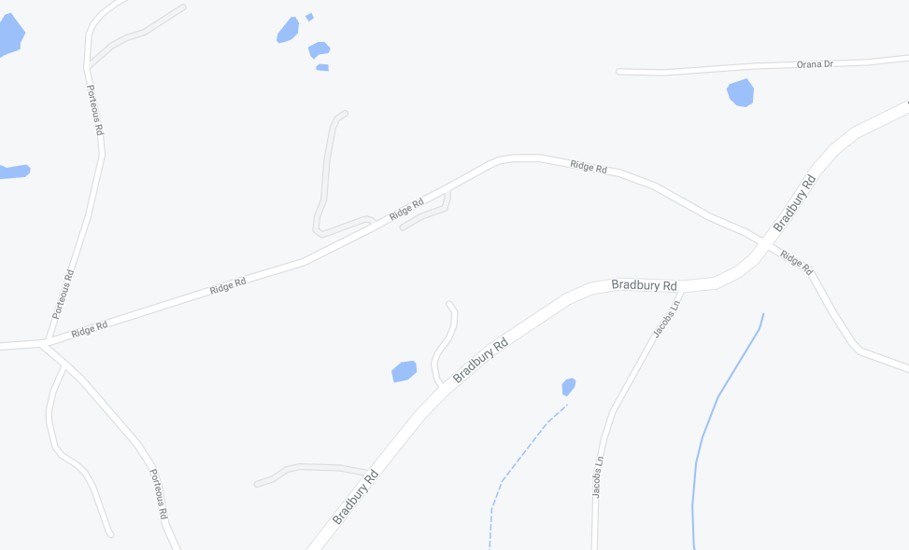
EVENT AHEAD
EVENT AHEAD
EVENT AHEAD
EVENT AHEAD
SAFETY CONES
EVENT AHEAD
PORTEOUS RD
PORTEOUS RD
RIDGE ROAD
BRADBURY ROAD
RIDGE ROAD
BRADBURY ROAD

ZONE 3: RIDGE RD AND LONGWOOD RD INTERSECTION
ALL SIGNAGE IS PLACED WITHIN A STANDARD 80KM SPEED ZONE

MULTI MESSAGE
Event AHEAD
Event bike
Speed restriction ahead - 40

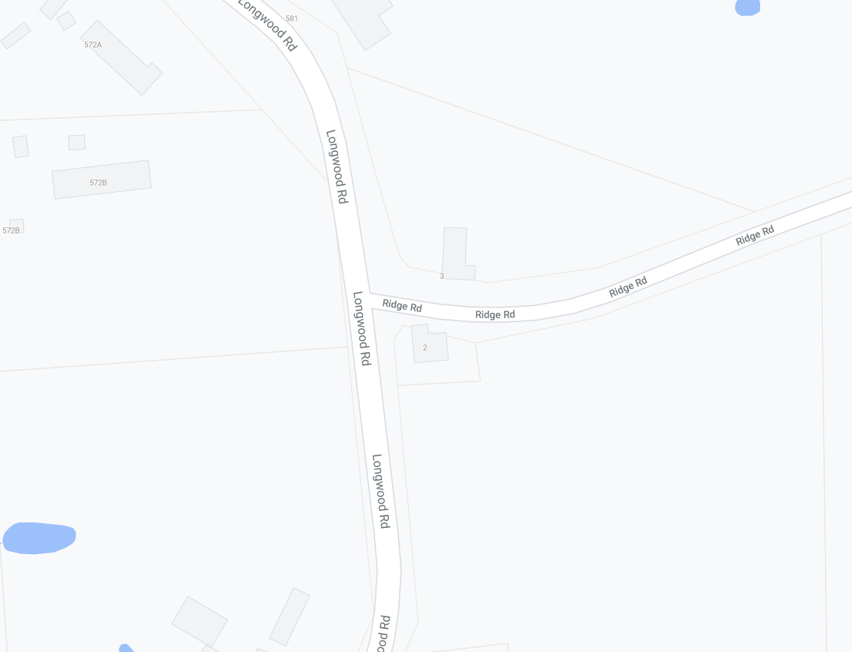
MARSHAL
MULTI MESSAGE (X2)
PREPARED TO STOP
SYMBOLIC CONTROLLER
Speed restriction – 40
Speed resumption – 80
END EVENT

MULTI MESSAGE
Event AHEAD
Event bike
Speed restriction ahead - 40
MULTI MESSAGE (X2)
PREPARED TO STOP
SYMBOLIC CONTROLLER
Speed restriction – 40
Speed resumption - 80

LONGWOOD ROAD
LONGWOOD ROAD
RIDGE ROAD
MARSHAL

ZONE 4:
LONGWOOD RD AND BRADBURY RD INTERSECTION
POTTERY RD AND BRADBURY RD INTERSECTION
ON BRADBURY RD, ALL SIGNAGE IS PLACED WITHIN A STANDARD 80KM SPEED ZONE
ON POTTERY RD, ALL SIGNAGE IS PLACED WITHIN A STANDARD 60KM SPEED ZONE

SPEED RESUMPTION - 80
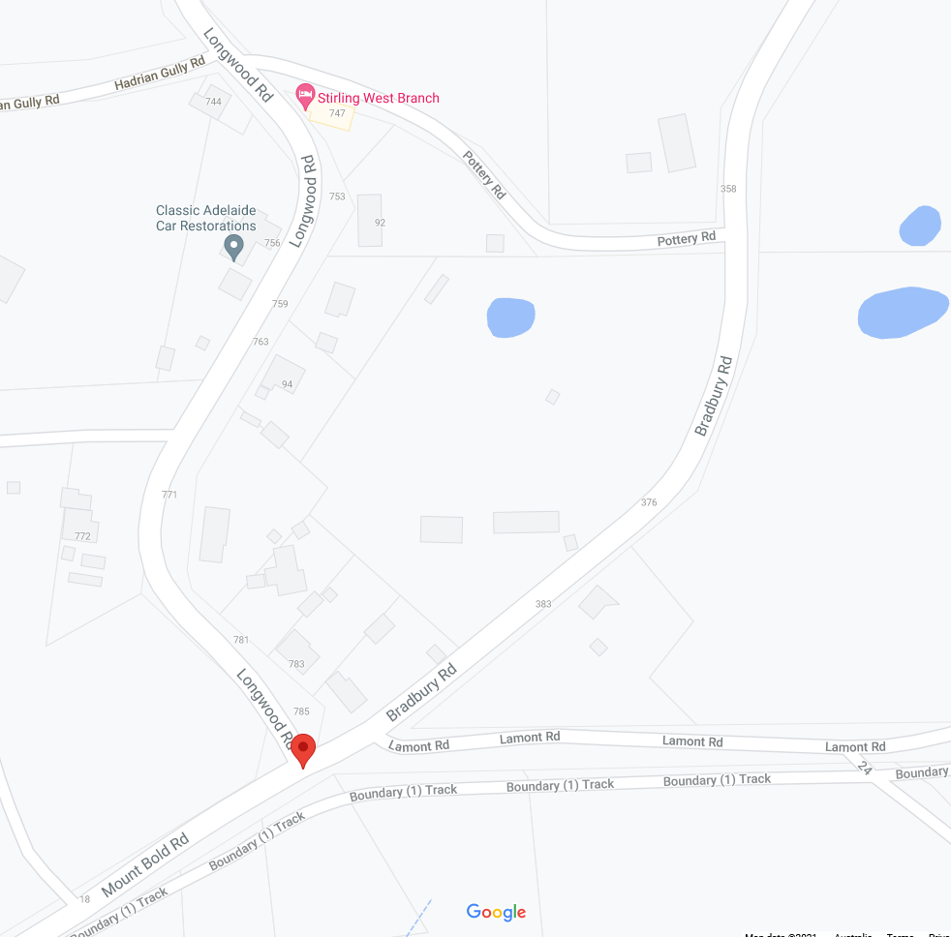
MARSHAL
Speed Restriction - 40
Speed Restriction - 50
POTTERY ROAD
Event AHEAD
MARSHAL
MULTI MESSAGE (X2)
PREPARED TO STOP
SYMBOLIC CONTROLLER
Speed restriction – 40
Speed resumption – 80
END EVENT

Event AHEAD
HADRIAN GULLY RD
BRADBURY ROAD
LONGWOOD ROAD
MULTI MESSAGE
Event AHEAD
Event bike
Speed restriction 40
MULTI MESSAGE
Event AHEAD
Event bike
Speed restriction ahead - 40

