 CORKSCREW RD HILL CLIMB SIGNAGE MAP
Distance:
From start to finish point = 7.9 km

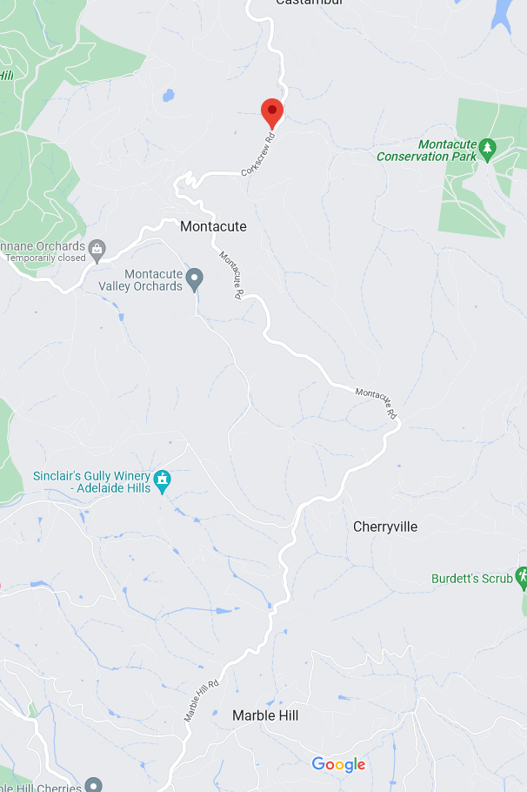
ZONE 3: See detailed map below
ZONE 2: See detailed map below
ZONE 1:
See detailed
map below
CORKSCREW RD
START
Sixth Creek Bridge, Corkscrew Rd
CHERRYVILLE
MONTACUTE
MONTACUTE RD
MONTACUTE RD
MARBLE HILL RD
FINISH
Marble Hill
MARBLE HILL RUINS
60
60
80
80
ZONE 1: START AREA
ALL SIGNAGE IS PLACED WITHIN A STANDARD 70KM SPEED ZONE

Start point: is at the Sixth Creek Bridge on Corkscrew Road.
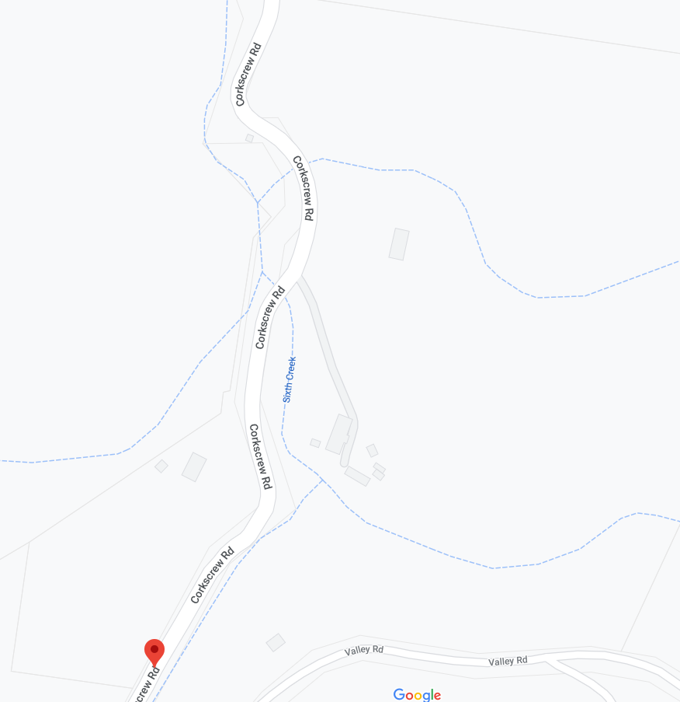
MULTI MESSAGE (X1)
PREPARED TO STOP
SYMBILC CONTROLLER
Speed restriction – 40
REVERSE:
Speed resumption – 70
END EVENT

40 AHEAD
Event AHEAD
Speed restriction – 40
South (heading up the hill)
MARSHAL
BRIDGE
START
CORKSCREW RD
CORKSCREW RD

ZONE 2: CORKSCREW RD AND MONTACUTE RD INTERSECTION
ALL SIGNAGE IS PLACED WITHIN A STANDARD 80KM SPEED ZONE

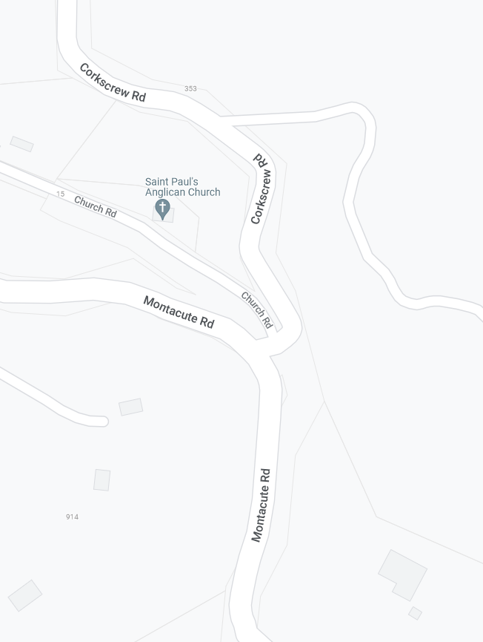
MULTI MESSAGE (X1)
PREPARED TO STOP
SYMBOILC CONTROLLER
Speed restriction – 40
REVERSE
END EVENT

SAFETY CONES
MULTI MESSAGE (X1)
Event AHEAD
Event bike
Speed restriction ahead - 40
MARSHAL
Speed restriction – 40
Event AHEAD
SPOTTER
SPEED RESUMPTION - 80
Event AHEAD

ZONE 3: FINISH AREA
ALL SIGNAGE IS PLACED WITHIN A STANDARD 80KM SPEED ZONE

MULTI MESSAGE (1)
Event AHEAD
Event bike
Speed restriction ahead - 40
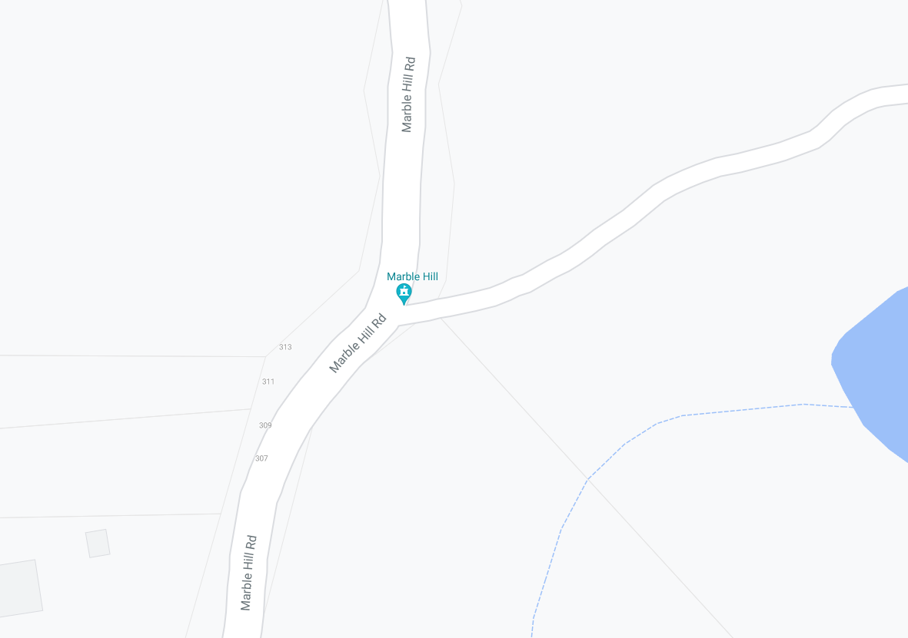
MULTI MESSAGE (1)
PREPARE TO STOP
SYMBOLIC CONTROLLER
Speed restriction – 40
REVERSE:
Speed resumption – 80
END EVENT

MULTI MESSAGE (1)
Event AHEAD
Event bike
Speed restriction ahead - 40
MULTI MESSAGE (1)
PREPARE TO STOP
SYMBOLIC CONTROLLER
Speed restriction – 40
REVERSE:
Speed resumption – 80
END EVENT

80kph fixed sign – covered for duration of event
MARBLE HILL RD
MARBLE HILL RD
Finish

