ADELAIDE HILLS CYCLING CLUB – FOX CREEK COURSE
Distances:
First lap from start to finish point: 17 km
Full loop from finish point: 16.6 km

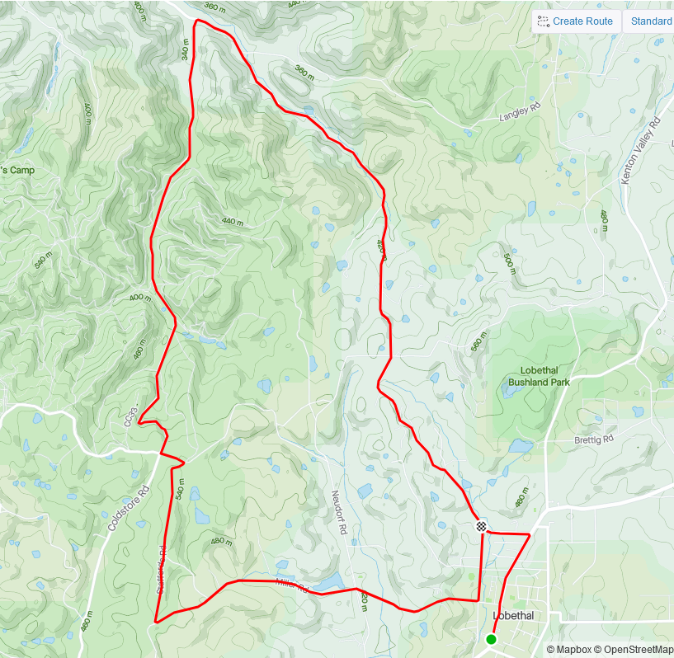
ZONE 3: See detailed map below
LOBETHAL
ZONE 2: See detailed map below
ZONE 6: See detailed map below
ZONE 1: See detailed map below
ZONE 5: See detailed map below
ZONE 4: See detailed map below
START (Bierhaus car park – 3A Main Street)
FINISH
STAFFORDS RD
CUDLEE CREEK RD
CUDLEE CREEK RD
CROFT RD
POST OFFICE RD
MILLER RD
FOX CREEK RD

ZONE 1: START
ALL SIGNAGE IS PLACED WITHIN A 50KM SPEED ZONE

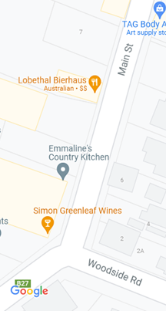
LOBETHAL
Event AHEAD
START
ZONE 2: PIONEER AVE – MILL RD INTERSECTION
ALL SIGNAGE IS PLACED WITHIN A 60KM SPEED ZONE ON PIONEER AVE

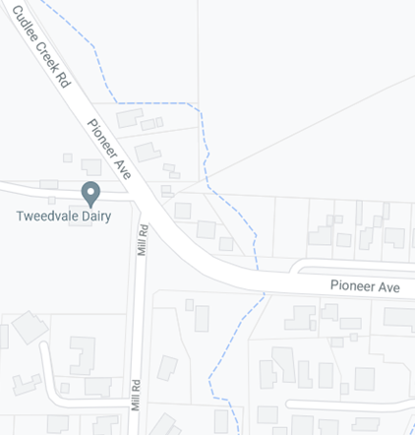
Marshal
MULTI MESSAGE (X2)
Prepare to stop
SYMBOLIC CONTROLLER
Speed Restriction – 40
Event AHEAD
SAFETY CONES
80
60

ZONE 3: CUDLEE CREEK RD – FOX CREEK RD INTERSECTION
ALL SIGNAGE IS PLACED WITHIN AN 80KM SPEED ZONE

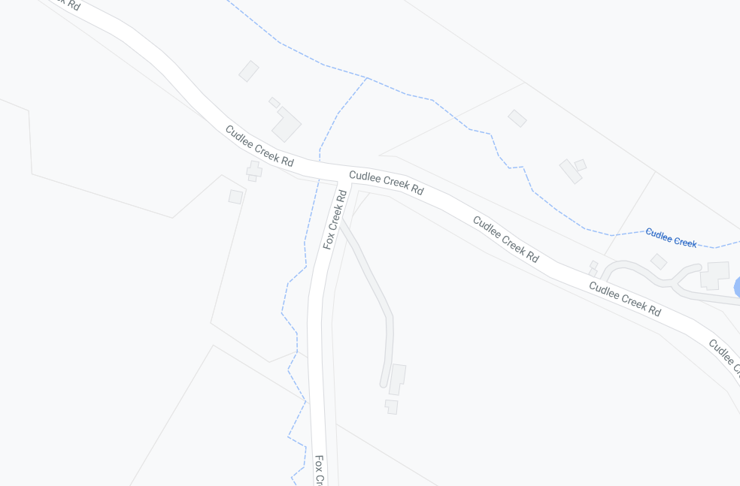
SAFETY CONES
Event AHEAD
80
FOX CREEK RD
CUDLEE CREEK RD
80
80

ZONE 4: STAFFORDS RD – MILLER RD INTERSECTION & BORAL QUARRIES
ALL SIGNAGE IS PLACED WITHIN AN 80KM SPEED ZONE

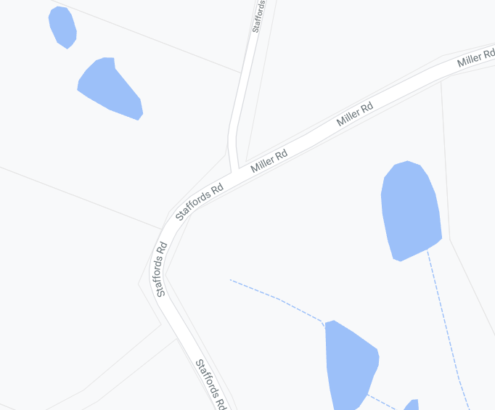
Marshal
MULTI MEASSAGE (X2)
Prepare to stop
SYMBOLIC CONTROLLER
Speed Restriction – 40
Speed Resumption - 80
Marshal
MULTI MEASSAGE (X2)
Prepare to stop
SYMBOLIC CONTROLLER
Speed Restriction – 40
Speed Resumption – 80
END EVENT
MULTI MESSAGE
Event AHEAD
Event bike
Speed restriction ahead - 40
WARNING SIGN FOR CYCLISTS
MULTI MESSAGE
Event AHEAD
Event bike
Speed restriction ahead - 40
STAFFORDS RD

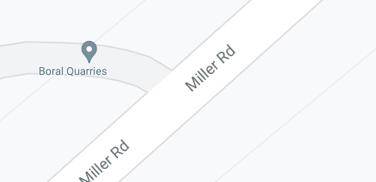
SAFETY CONES
placed along centre of the road over an unsafe gap in the road surface
Keep left sign for riders

ZONE 5: MILLER, NEUDORF AND POST OFFICE RDS INTERSECTION
ALL SIGNAGE IS PLACED WITHIN AN 80KM SPEED ZONE

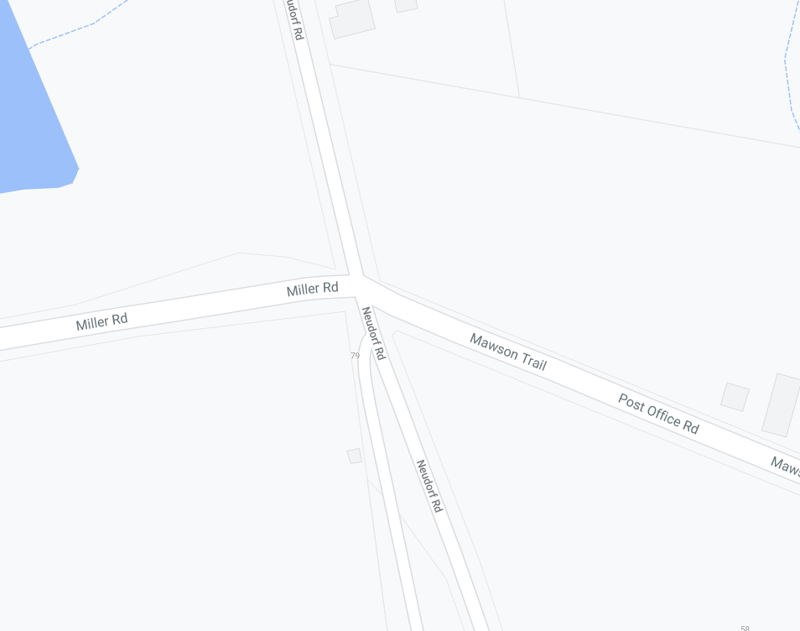
SPOTTER
Marshal
MULTI MESSAGE
Event AHEAD
Event bike
Speed restriction ahead - 40
MULTI MEASSAGE (X2)
Prepare to stop
SYMBOLIC CONTROLLER
Speed Restriction – 40
Speed Resumption – 80
END EVENT
MULTI MEASSAGE (X2)
Prepare to stop
SYMBOLIC CONTROLLER
Speed Restriction – 40
Speed Resumption – 80
END EVENT
MULTI MESSAGE
Event AHEAD
Event bike
Speed restriction ahead - 40
80
Marshal
80
80
80
NEUDORF RD RD
POST OFFICE RD

ZONE 6A: FINISH

SIGNAGE IS PLACED WITHIN BOTH 80KM AND 50KM SPEED ZONES

MULTI MESSAGE
Event AHEAD
Event bike
Speed restriction ahead - 40
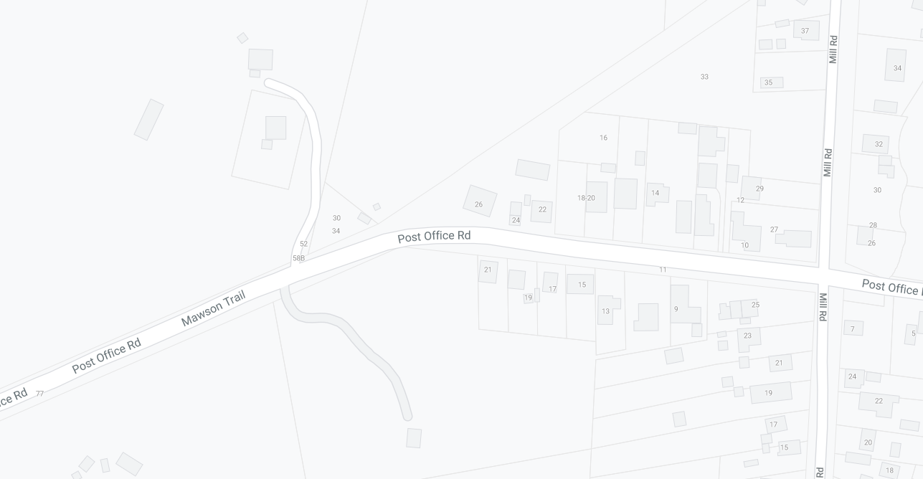
MULTI MEASSAGE (X2)
Prepare to stop
SYMBOLIC CONTROLLER
Speed Restriction – 40
Speed Resumption - 80
FINISH
POST OFFICE RD
MILL RD
MILL RD
POST OFFICE RD
80
50

ZONE 6B: POST OFFICE AND MILL RD INTERSECTION, AND MILL RD (NORTH)
SIGNAGE IS PLACED WITHIN A 50KM SPEED ZONE

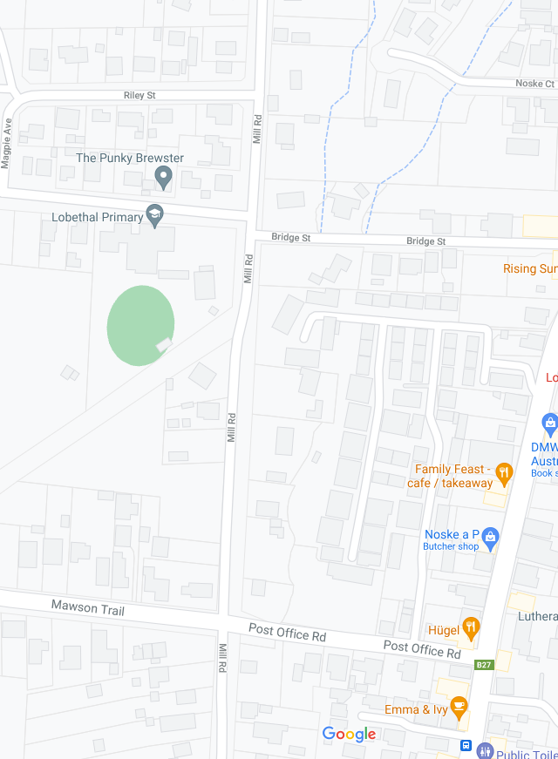
SPEED RESUMPTION - 50
MILL RD
POST OFFICE RD
RILEY ST
SCHOOL RD
Event AHEAD
MULTI MEASSAGE (X2)
Prepare to stop
SYMBOLIC CONTROLLER
Speed Restriction – 40
Speed Resumption – 50
END EVENT
Marshal
Event AHEAD
MULTI MEASSAGE (X2)
Prepare to stop
SYMBOLIC CONTROLLER
Speed Restriction – 40
Speed Resumption - 50

SPEED RESTRICTION - 40
Event AHEAD
Marshal
Event AHEAD
SPEED RESUMPTION - 50
Event AHEAD

